Supplementary Figure Legends:
Supplementary Figure 1. Dot density diagram for sample #1 with all CpGs
Supplementary Figure 2. Dot density diagram for sample #1 by removing CpG sites with a minimum methylation beta value> 0.8 or a maximum beta value<0.2
Supplementary Figure 3. R² of the 169 samples by removing CpG sites with a minimum methylation beta value> 0.9 or a maximum beta value<0.1
Supplementary Figure 4. R² of the 169 samples by removing CpG sites with a minimum methylation beta value> 0.8 or a maximum beta value<0.2
Supplementary Figure 5. Scatter plots of measured placenta beta values-cord blood beta values, and measured placenta beta values-predicted placenta beta values by single-CpG-based SVM for sample #1 to #9
Supplementary Figure 6. Scatter plots of measured placenta beta values-cord blood beta values, and measured placenta beta values-predicted placenta beta values by single-CpG-based SVM for sample #10 to #18
Supplementary Figure 7. Scatter plots of measured placenta beta values-cord blood beta values, and measured placenta beta values-predicted placenta beta values by single-CpG-based SVM for sample #19 to #27
Supplementary Figure 8. Scatter plots of measured placenta beta values-cord blood beta values, and measured placenta beta values-predicted placenta beta values by single-CpG-based SVM for sample #28 to #36
Supplementary Figure 9. Scatter plots of measured placenta beta values-cord blood beta values, and measured placenta beta values-predicted placenta beta values by single-CpG-based SVM for sample #37 to #45
Supplementary Figure 10. Scatter plots of measured placenta beta values-cord blood beta values, and measured placenta beta values-predicted placenta beta values by single-CpG-based SVM for sample #46 to #54
Supplementary Figure 11. Scatter plots of measured placenta beta values-cord blood beta values, and measured placenta beta values-predicted placenta beta values by single-CpG-based SVM for sample #55 to #63
Supplementary Figure 12. Scatter plots of measured placenta beta values-cord blood beta values, and measured placenta beta values-predicted placenta beta values by single-CpG-based SVM for sample #64 to #72
Supplementary Figure 13. Scatter plots of measured placenta beta values-cord blood beta values, and measured placenta beta values-predicted placenta beta values by single-CpG-based SVM for sample #73 to #81
Supplementary Figure 14. Scatter plots of measured placenta beta values-cord blood beta values, and measured placenta beta values-predicted placenta beta values by single-CpG-based SVM for sample #82 to #90
Supplementary Figure 15. Scatter plots of measured placenta beta values-cord blood beta values, and measured placenta beta values-predicted placenta beta values by single-CpG-based SVM for sample #91 to #99
Supplementary Figure 16. Scatter plots of measured placenta beta values-cord blood beta values, and measured placenta beta values-predicted placenta beta values by single-CpG-based SVM for sample #100 to #108
Supplementary Figure 17. Scatter plots of measured placenta beta values-cord blood beta values, and measured placenta beta values-predicted placenta beta values by single-CpG-based SVM for sample #109 to #117
Supplementary Figure 18. Scatter plots of measured placenta beta values-cord blood beta values, and measured placenta beta values-predicted placenta beta values by single-CpG-based SVM for sample #118 to #126
Supplementary Figure 19. Scatter plots of measured placenta beta values-cord blood beta values, and measured placenta beta values-predicted placenta beta values by single-CpG-based SVM for sample #127 to #135
Supplementary Figure 20. Scatter plots of measured placenta beta values-cord blood beta values, and measured placenta beta values-predicted placenta beta values by single-CpG-based SVM for sample #136 to #144
Supplementary Figure 21. Scatter plots of measured placenta beta values-cord blood beta values, and measured placenta beta values-predicted placenta beta values by single-CpG-based SVM for sample #145 to #153
Supplementary Figure 22. Scatter plots of measured placenta beta values-cord blood beta values, and measured placenta beta values-predicted placenta beta values by single-CpG-based SVM for sample #154 to #162
Supplementary Figure 23. Scatter plots of measured placenta beta values-cord blood beta values, and measured placenta beta values-predicted placenta beta values by single-CpG-based SVM for sample #163 to #169
Supplementary Figure 24. Scatter plots of measured cord blood beta values, measured placenta beta values and predicted placenta beta values by single-CpG-based SVM for sample #1 to #9
Supplementary Figure 25. Scatter plots of measured cord blood beta values, measured placenta beta values and predicted placenta beta values by single-CpG-based SVM for sample #10 to #18
Supplementary Figure 26. Scatter plots of measured cord blood beta values, measured placenta beta values and predicted placenta beta values by single-CpG-based SVM for sample #19 to #27
Supplementary Figure 27. Scatter plots of measured cord blood beta values, measured placenta beta values and predicted placenta beta values by single-CpG-based SVM for sample #28 to #36
Supplementary Figure 28. Scatter plots of measured cord blood beta values, measured placenta beta values and predicted placenta beta values by single-CpG-based SVM for sample #37 to #45
Supplementary Figure 29. Scatter plots of measured cord blood beta values, measured placenta beta values and predicted placenta beta values by single-CpG-based SVM for sample #46 to #54
Supplementary Figure 30. Scatter plots of measured cord blood beta values, measured placenta beta values and predicted placenta beta values by single-CpG-based SVM for sample #55 to #63
Supplementary Figure 31. Scatter plots of measured cord blood beta values, measured placenta beta values and predicted placenta beta values by single-CpG-based SVM for sample #64 to #72
Supplementary Figure 32. Scatter plots of measured cord blood beta values, measured placenta beta values and predicted placenta beta values by single-CpG-based SVM for sample #73 to #81
Supplementary Figure 33. Scatter plots of measured cord blood beta values, measured placenta beta values and predicted placenta beta values by single-CpG-based SVM for sample #82 to #90
Supplementary Figure 34. Scatter plots of measured cord blood beta values, measured placenta beta values and predicted placenta beta values by single-CpG-based SVM for sample #91 to #99
Supplementary Figure 35. Scatter plots of measured cord blood beta values, measured placenta beta values and predicted placenta beta values by single-CpG-based SVM for sample #100 to #108
Supplementary Figure 36. Scatter plots of measured cord blood beta values, measured placenta beta values and predicted placenta beta values by single-CpG-based SVM for sample #109 to #117
Supplementary Figure 37. Scatter plots of measured cord blood beta values, measured placenta beta values and predicted placenta beta values by single-CpG-based SVM for sample #118 to #126
Supplementary Figure 38. Scatter plots of measured cord blood beta values, measured placenta beta values and predicted placenta beta values by single-CpG-based SVM for sample #126 to #135
Supplementary Figure 39. Scatter plots of measured cord blood beta values, measured placenta beta values and predicted placenta beta values by single-CpG-based SVM for sample #136 to #144
Supplementary Figure 40. Scatter plots of measured cord blood beta values, measured placenta beta values and predicted placenta beta values by single-CpG-based SVM for sample #145 to #153
Supplementary Figure 41. Scatter plots of measured cord blood beta values, measured placenta beta values and predicted placenta beta values by single-CpG-based SVM for sample #154 to #162
Supplementary Figure 42. Scatter plots of measured cord blood beta values, measured placenta beta values and predicted placenta beta values by single-CpG-based SVM for sample #163 to #169
Supplementary Figure 43. Clustering of measured placenta methylation, predicted placenta methylation and measured cord blood methylation

Supplementary Figure 1. Dot density diagram for sample #1 with all CpGs
The y-axis is measured methylation beta values in placenta and the x-axis is measured methylation beta values in cord blood. The green represents low dots density and the red represents high dots density (using ggplot2 R package, methylation beta values are round to the nearest tenth).

Supplementary Figure 2. Dot density diagram for sample #1 by removing CpG sites with a minimum methylation beta value> 0.8 or a maximum beta value<0.2
The y-axis is measured methylation beta values in placenta and the x-axis is measured methylation beta values in cord blood. The green represents low dots density and the red represents high dots density (using ggplot2 R package, methylation beta values are round to the nearest tenth).
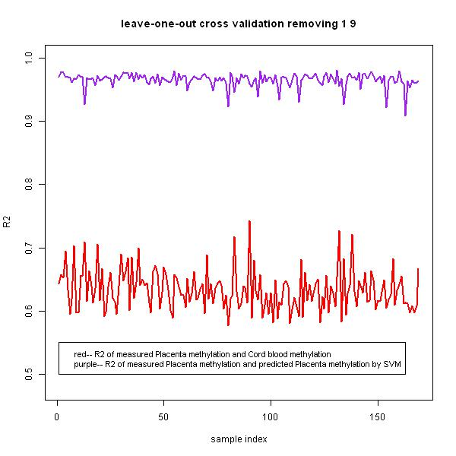
Supplementary Figure 3. R² of the 169 samples by removing CpG sites with a minimum methylation beta value> 0.9 or a maximum beta value<0.1
The x-axis represents the sample index from 1 to 169, the y-axis represents the CpG-wise R² of the 169 samples. The red line represents the CpG-wise R² of measured cord blood beta values and measured placenta beta values, and the purple line represents the CpG-wise R² of measured placenta beta values and predicted placenta beta values by single-CpG-based SVM.

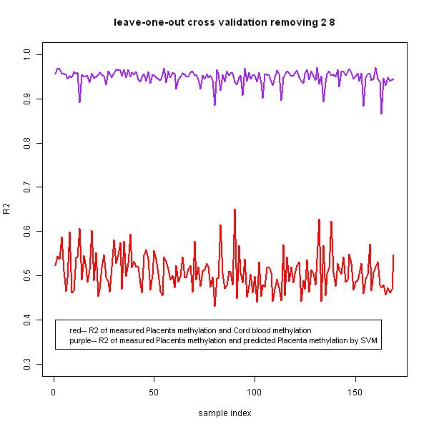
Supplementary Figure 4. R² of the 169 samples by removing CpG sites with a minimum methylation beta value> 0.8 or a maximum beta value<0.2
The x-axis represents the sample index from 1 to 169, the y-axis represents the CpG-wise R² of the 169 samples. The red line represents the CpG-wise R² of measured cord blood beta values and measured placenta beta values, and the purple line represents the CpG-wise R² of measured placenta beta values and predicted placenta beta values by single-CpG-based SVM.

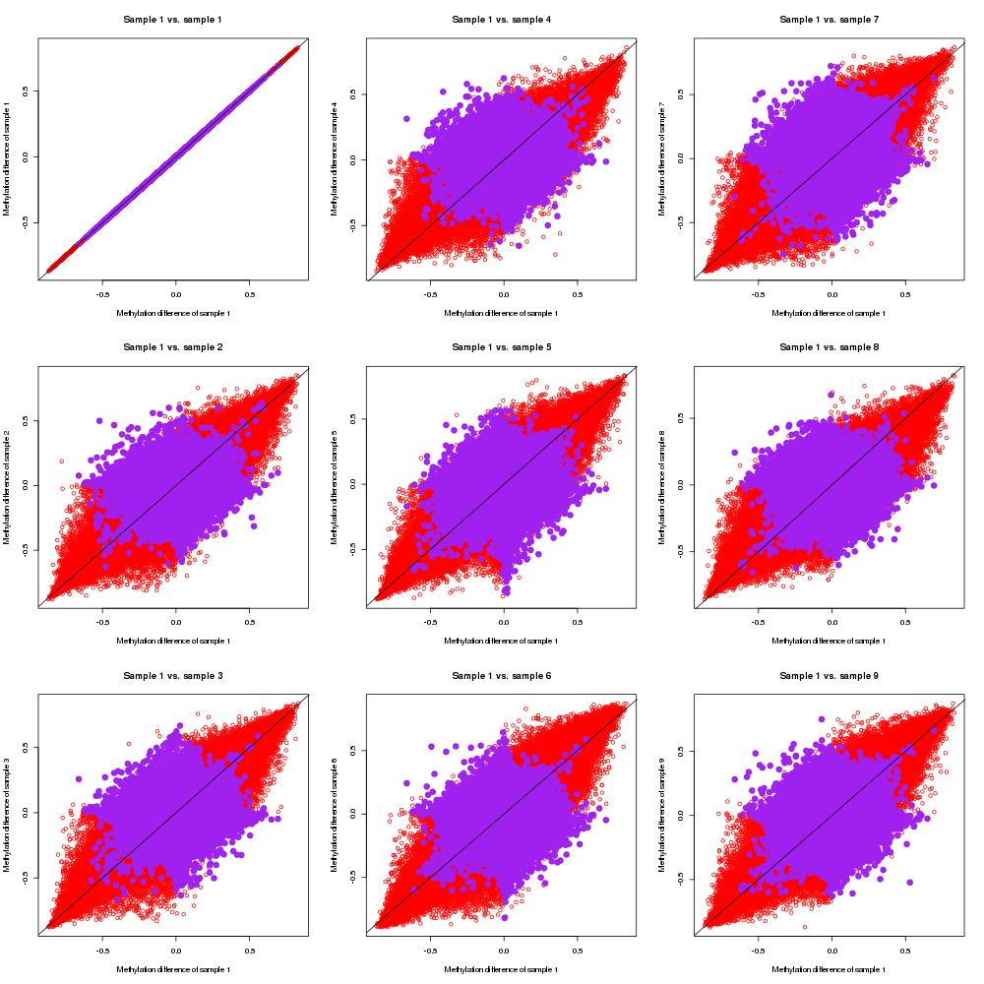
Supplementary Figure 5. Scatter plots of measured placenta beta values-cord blood beta values, and measured placenta beta values-predicted placenta beta values by single-CpG-based SVM for sample #1 to #9
Red dots indicate (measured placenta beta values–measured cord blood beta values) of sample #1 and (measured placenta beta values–measured cord blood beta values) of sample i (#1 to #9), and purple dots represent (measured placenta beta values–predicted placenta beta values by single-CpG-based SVM) of sample #1 and (measured placenta beta values–predicted placenta beta values by single-CpG-based SVM) of sample i.
Note: “–“ represents minus sign.

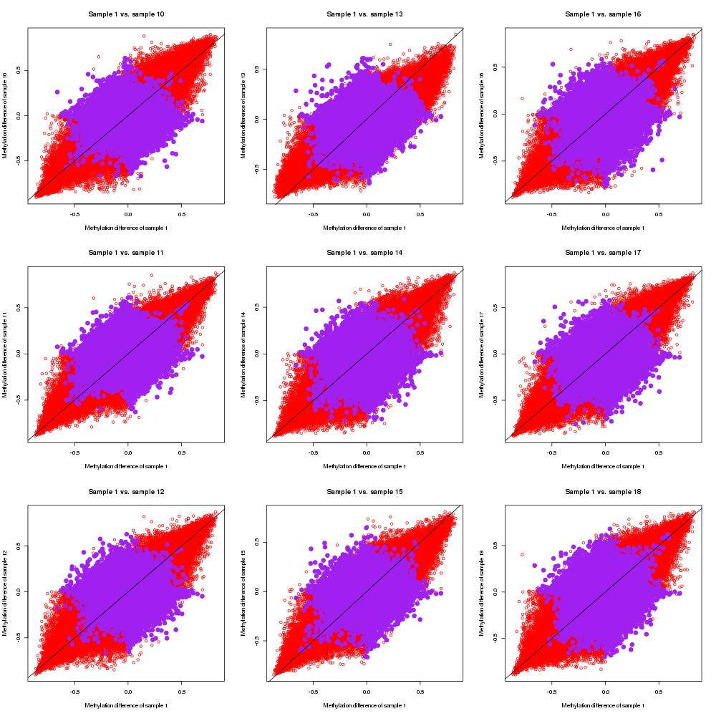
Supplementary Figure 6. Scatter plots of measured placenta beta values-cord blood beta values, and measured placenta beta values-predicted placenta beta values by single-CpG-based SVM for sample #10 to #18
Red dots indicate (measured placenta beta values–measured cord blood beta values) of sample #1 and (measured placenta beta values–measured cord blood beta values) of sample i (#10 to #18), and purple dots represent (measured placenta beta values–predicted placenta beta values by single-CpG-based SVM) of sample #1 and (measured placenta beta values–predicted placenta beta values by single-CpG-based SVM) of sample i.
Note: “–“ represents minus sign.

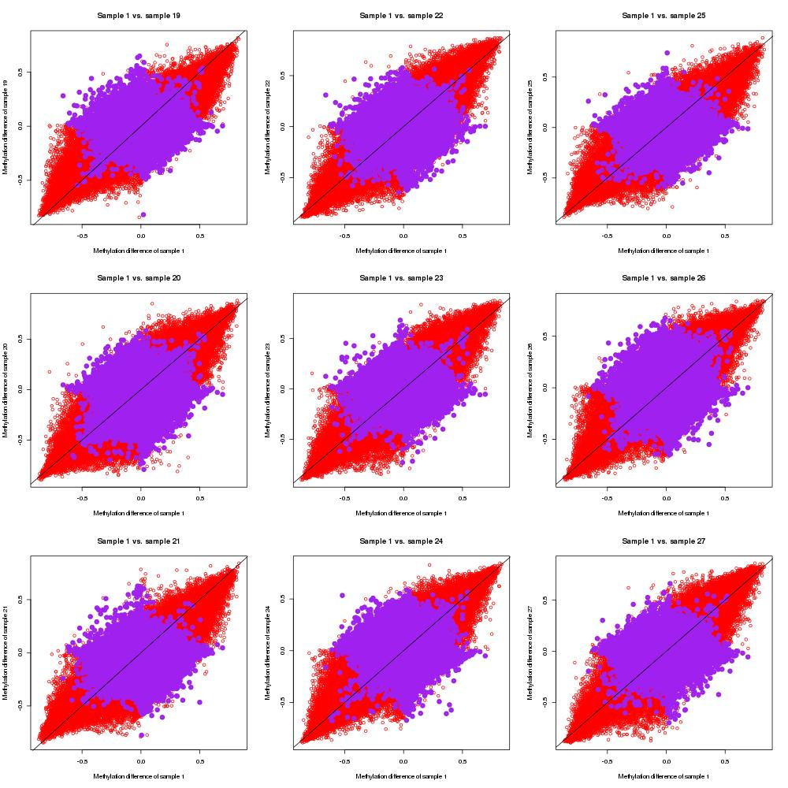
Supplementary Figure 7. Scatter plots of measured placenta beta values-cord blood beta values, and measured placenta beta values-predicted placenta beta values by single-CpG-based SVM for sample #19 to #27
Red dots indicate (measured placenta beta values–measured cord blood beta values) of sample #1 and (measured placenta beta values–measured cord blood beta values) of sample i (#19 to #27), and purple dots represent (measured placenta beta values–predicted placenta beta values by single-CpG-based SVM) of sample #1 and (measured placenta beta values–predicted placenta beta values by single-CpG-based SVM) of sample i.
Note: “–“ represents minus sign.

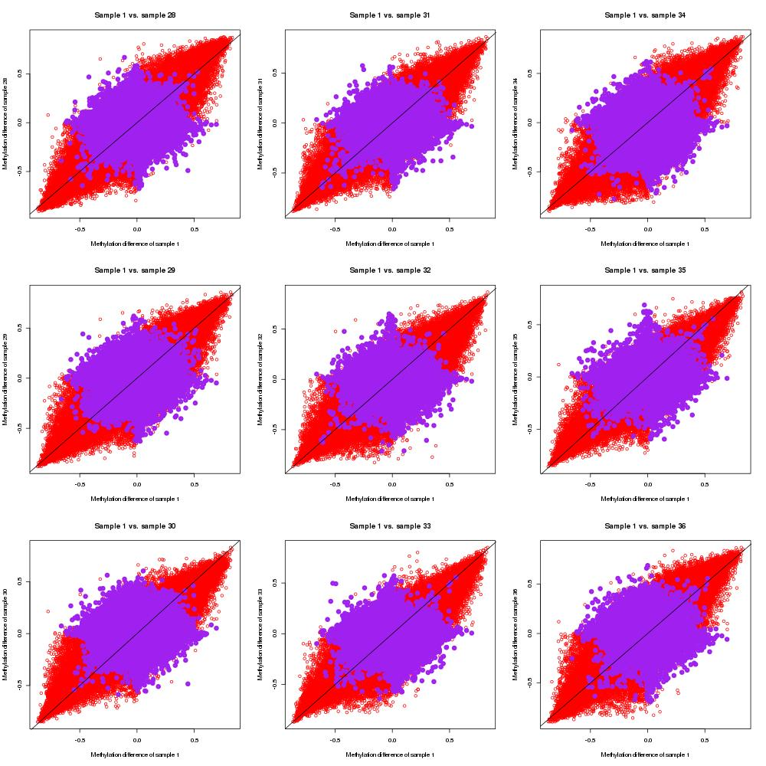
Supplementary Figure 8. Scatter plots of measured placenta beta values-cord blood beta values, and measured placenta beta values-predicted placenta beta values by single-CpG-based SVM for sample #28 to #36
Red dots indicate (measured placenta beta values–measured cord blood beta values) of sample #1 and (measured placenta beta values–measured cord blood beta values) of sample i (#28 to #36), and purple dots represent (measured placenta beta values–predicted placenta beta values by single-CpG-based SVM) of sample #1 and (measured placenta beta values–predicted placenta beta values by single-CpG-based SVM) of sample i.
Note: “–“ represents minus sign.
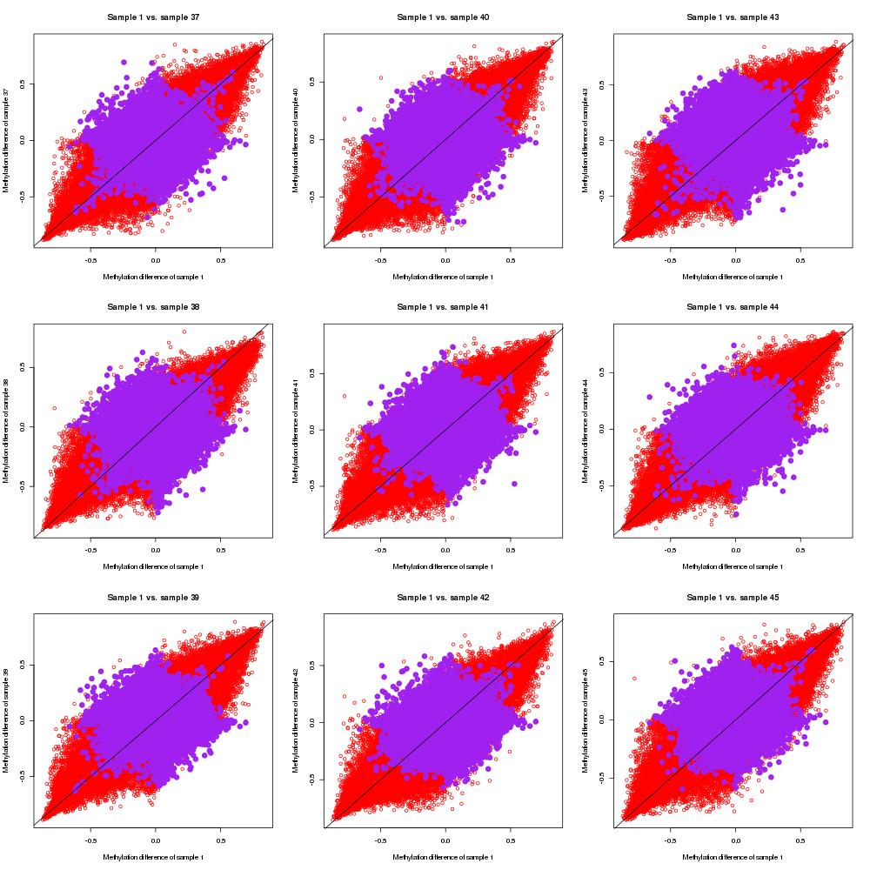Supplementary Figure 9. Scatter plots of measured placenta beta values-cord blood beta values, and measured placenta beta values-predicted placenta beta values by single-CpG-based SVM for sample #37 to #45
Red dots indicate (measured placenta beta values–measured cord blood beta values) of sample #1 and (measured placenta beta values–measured cord blood beta values) of sample i (#37 to #45), and purple dots represent (measured placenta beta values–predicted placenta beta values by single-CpG-based SVM) of sample #1 and (measured placenta beta values–predicted placenta beta values by single-CpG-based SVM) of sample i.
Note: “–“ represents minus sign.
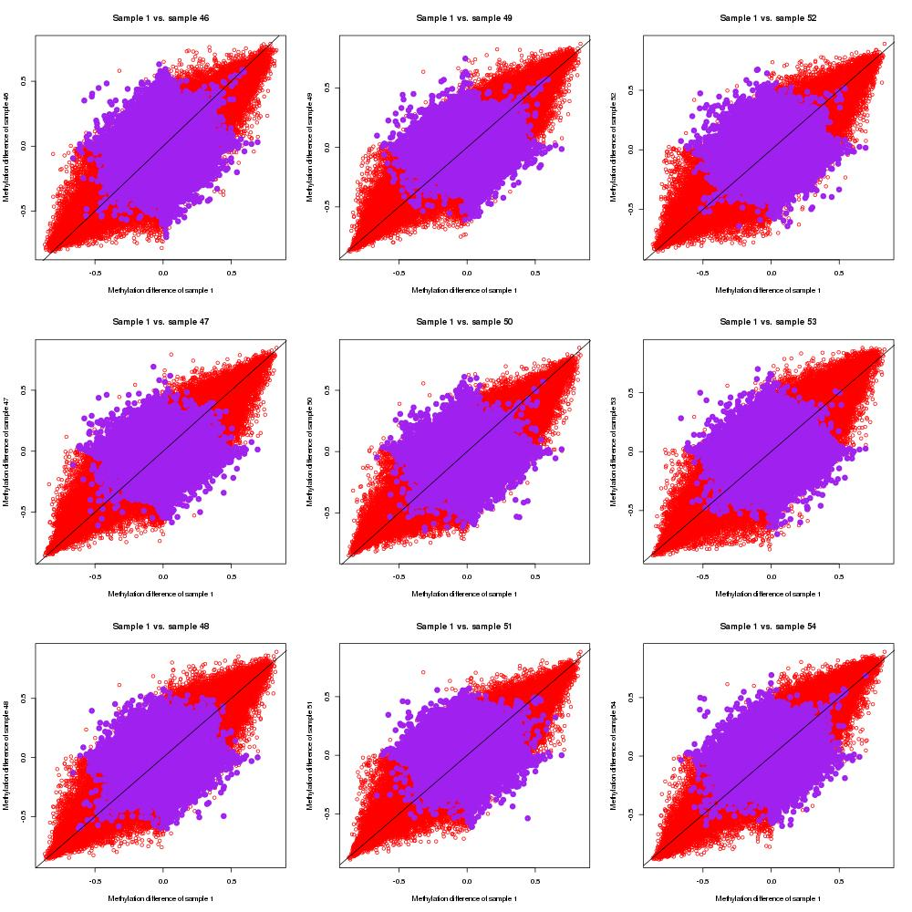Supplementary Figure 10. Scatter plots of measured placenta beta values-cord blood beta values, and measured placenta beta values-predicted placenta beta values by single-CpG-based SVM for sample #46 to #54
Red dots indicate (measured placenta beta values–measured cord blood beta values) of sample #1 and (measured placenta beta values–measured cord blood beta values) of sample i (#46 to #54), and purple dots represent (measured placenta beta values–predicted placenta beta values by single-CpG-based SVM) of sample #1 and (measured placenta beta values–predicted placenta beta values by single-CpG-based SVM) of sample i.
Note: “–“ represents minus sign.
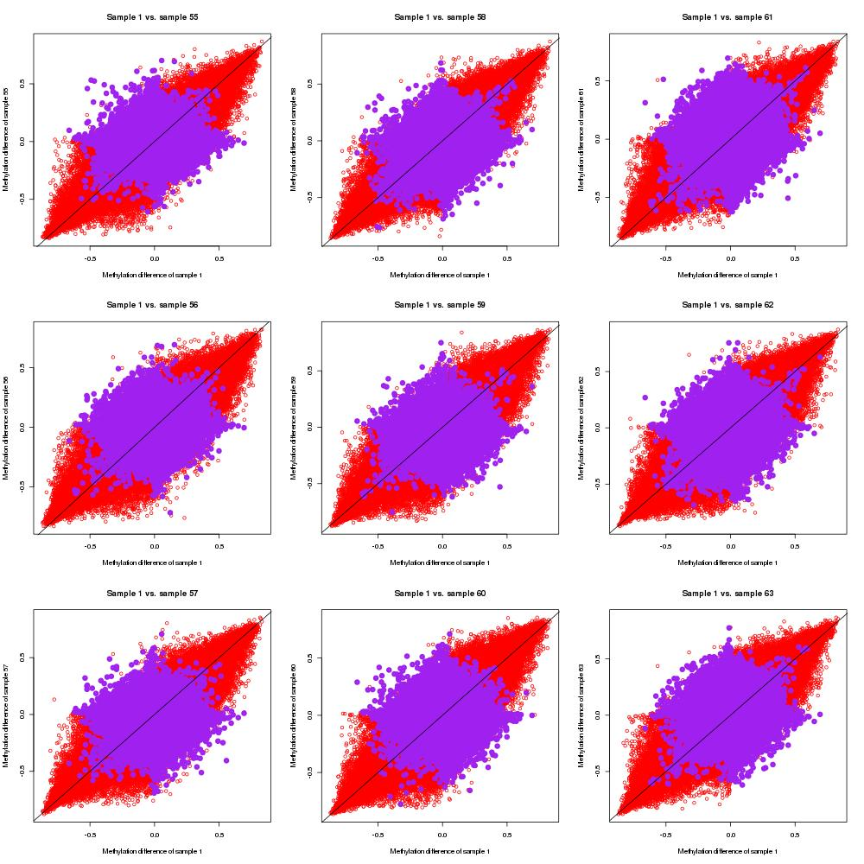Supplementary Figure 11. Scatter plots of measured placenta beta values-cord blood beta values, and measured placenta beta values-predicted placenta beta values by single-CpG-based SVM for sample #55 to #63
Red dots indicate (measured placenta beta values–measured cord blood beta values) of sample #1 and (measured placenta beta values–measured cord blood beta values) of sample i (#55 to #63), and purple dots represent (measured placenta beta values–predicted placenta beta values by single-CpG-based SVM) of sample #1 and (measured placenta beta values–predicted placenta beta values by single-CpG-based SVM) of sample i.
Note: “–“ represents minus sign.
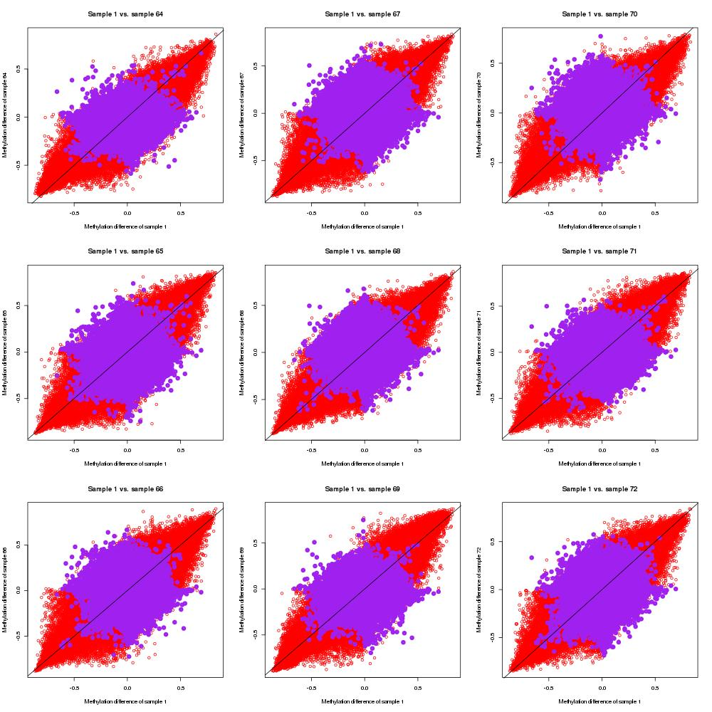Supplementary Figure 12. Scatter plots of measured placenta beta values-cord blood beta values, and measured placenta beta values-predicted placenta beta values by single-CpG-based SVM for sample #64 to #72
Red dots indicate (measured placenta beta values–measured cord blood beta values) of sample #1 and (measured placenta beta values–measured cord blood beta values) of sample i (#64 to #72), and purple dots represent (measured placenta beta values–predicted placenta beta values by single-CpG-based SVM) of sample #1 and (measured placenta beta values–predicted placenta beta values by single-CpG-based SVM) of sample i.
Note: “–“ represents minus sign.
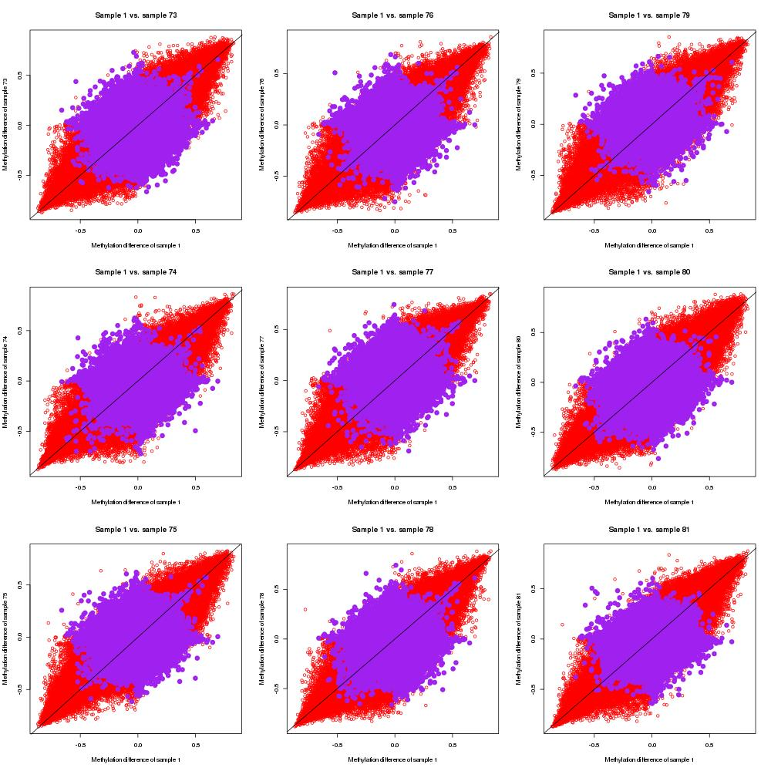Supplementary Figure 13. Scatter plots of measured placenta beta values-cord blood beta values, and measured placenta beta values-predicted placenta beta values by single-CpG-based SVM for sample #73 to #81
Red dots indicate (measured placenta beta values–measured cord blood beta values) of sample #1 and (measured placenta beta values–measured cord blood beta values) of sample i (#73 to #81), and purple dots represent (measured placenta beta values–predicted placenta beta values by single-CpG-based SVM) of sample #1 and (measured placenta beta values–predicted placenta beta values by single-CpG-based SVM) of sample i.
Note: “–“ represents minus sign.
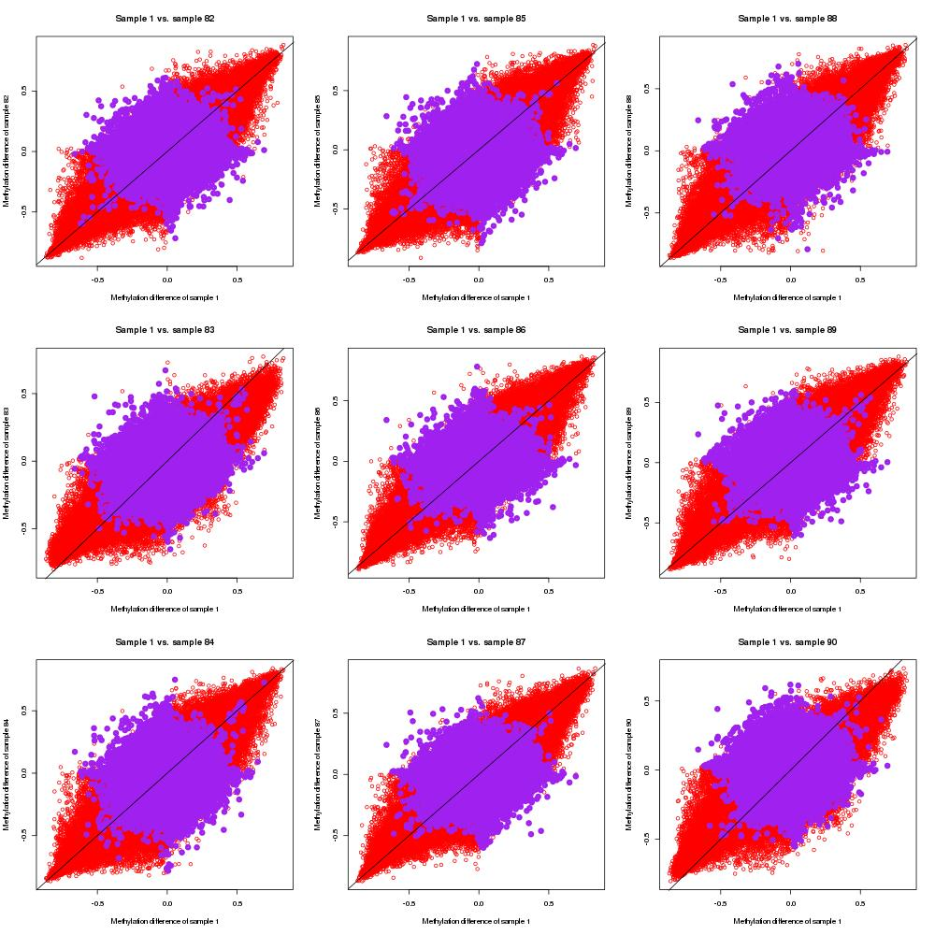Supplementary Figure 14. Scatter plots of measured placenta beta values-cord blood beta values, and measured placenta beta values-predicted placenta beta values by single-CpG-based SVM for sample #82 to #90
Red dots indicate (measured placenta beta values–measured cord blood beta values) of sample #1 and (measured placenta beta values–measured cord blood beta values) of sample i (#82 to #90), and purple dots represent (measured placenta beta values–predicted placenta beta values by single-CpG-based SVM) of sample #1 and (measured placenta beta values–predicted placenta beta values by single-CpG-based SVM) of sample i.
Note: “–“ represents minus sign.
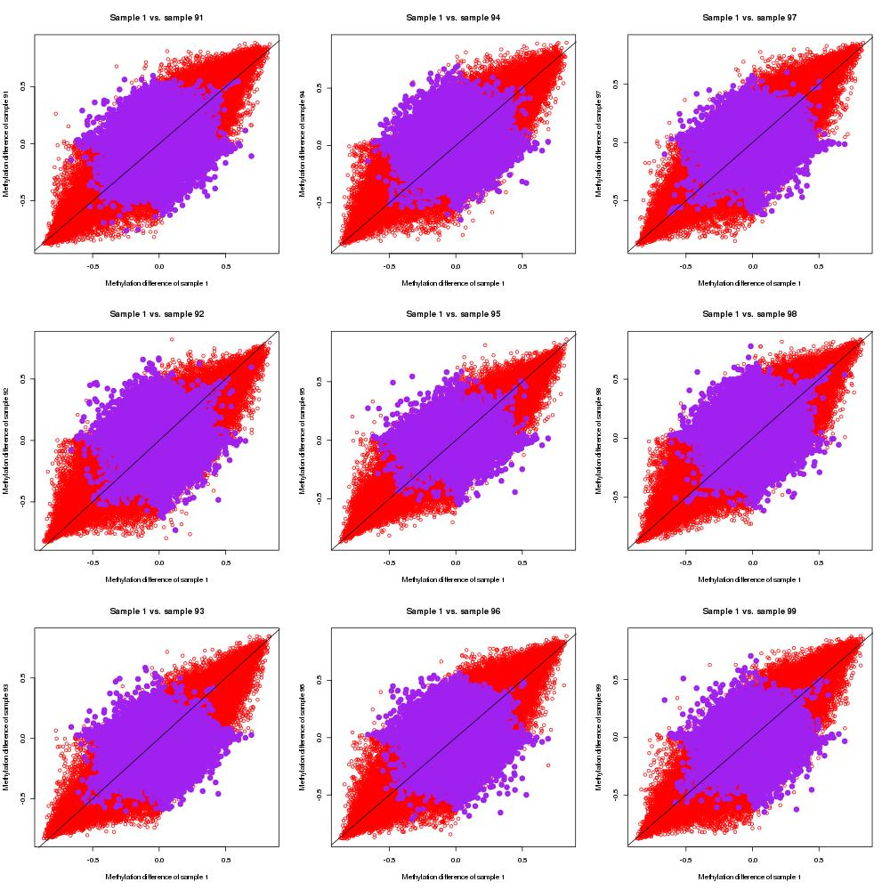Supplementary Figure 15. Scatter plots of measured placenta beta values-cord blood beta values, and measured placenta beta values-predicted placenta beta values by single-CpG-based SVM for sample #91 to #99
Red dots indicate (measured placenta beta values–measured cord blood beta values) of sample #1 and (measured placenta beta values–measured cord blood beta values) of sample i (#91 to #99), and purple dots represent (measured placenta beta values–predicted placenta beta values by single-CpG-based SVM) of sample #1 and (measured placenta beta values–predicted placenta beta values by single-CpG-based SVM) of sample i.
Note: “–“ represents minus sign.
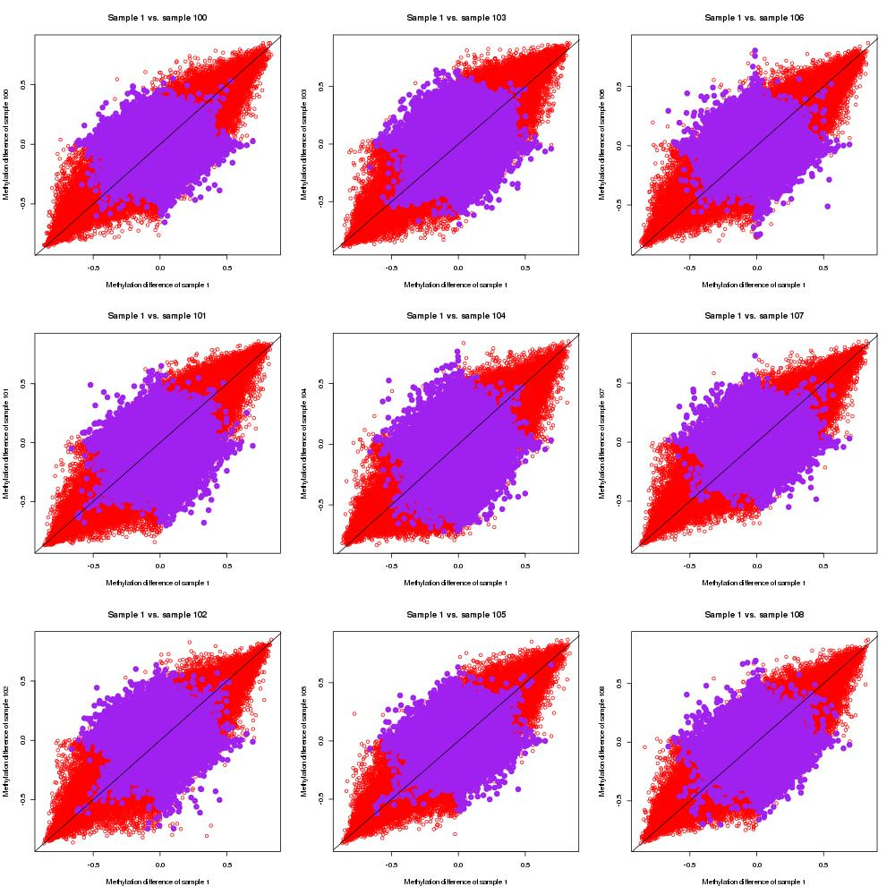Supplementary Figure 16. Scatter plots of measured placenta beta values-cord blood beta values, and measured placenta beta values-predicted placenta beta values by single-CpG-based SVM for sample #100 to #108
Red dots indicate (measured placenta beta values–measured cord blood beta values) of sample #1 and (measured placenta beta values–measured cord blood beta values) of sample i (#100 to #108), and purple dots represent (measured placenta beta values–predicted placenta beta values by single-CpG-based SVM) of sample #1 and (measured placenta beta values–predicted placenta beta values by single-CpG-based SVM) of sample i.
Note: “–“ represents minus sign.
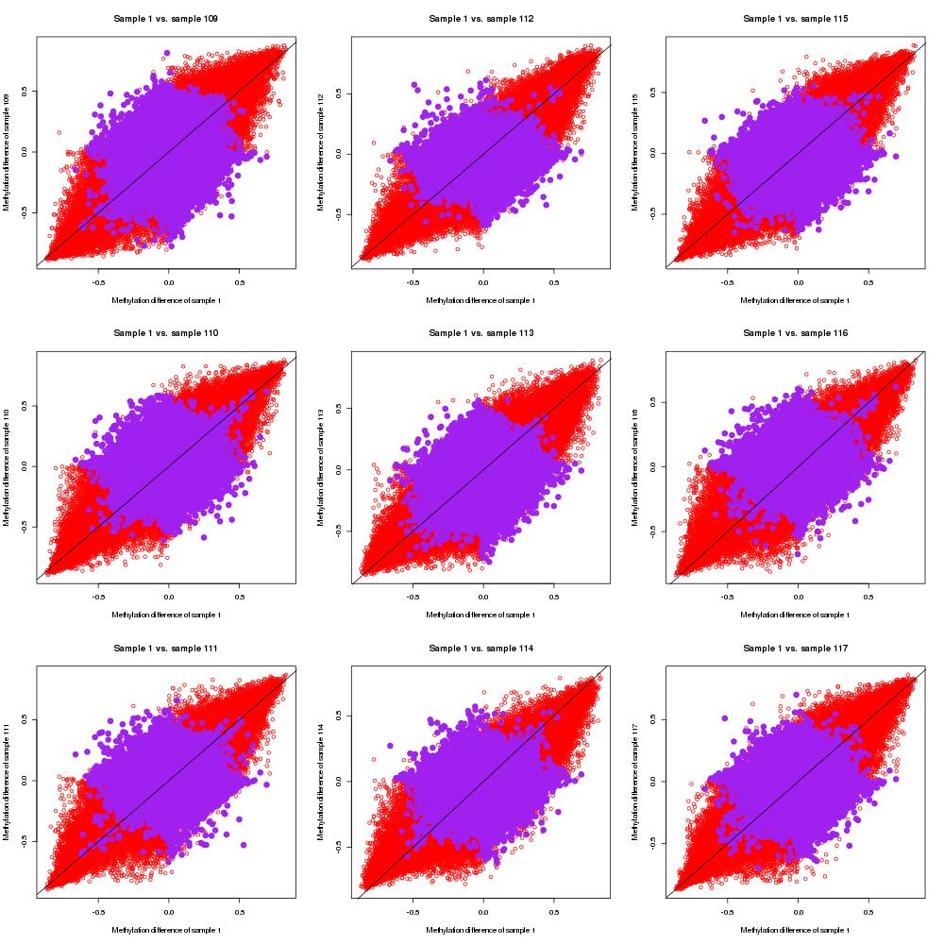Supplementary Figure 17. Scatter plots of measured placenta beta values-cord blood beta values, and measured placenta beta values-predicted placenta beta values by single-CpG-based SVM for sample #109 to #117
Red dots indicate (measured placenta beta values–measured cord blood beta values) of sample #1 and (measured placenta beta values–measured cord blood beta values) of sample i (#109 to #117), and purple dots represent (measured placenta beta values–predicted placenta beta values by single-CpG-based SVM) of sample #1 and (measured placenta beta values–predicted placenta beta values by single-CpG-based SVM) of sample i.
Note: “–“ represents minus sign.
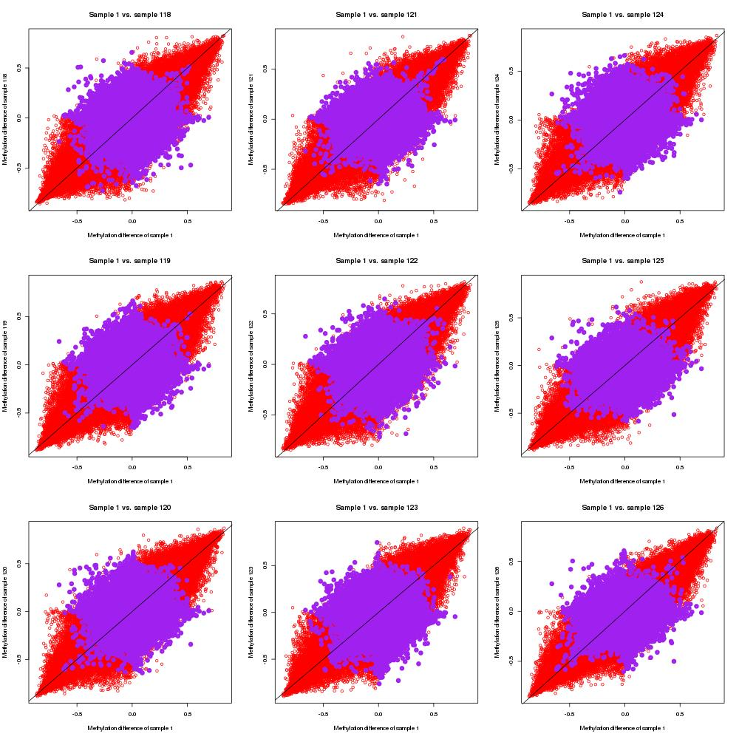Supplementary Figure 18. Scatter plots of measured placenta beta values-cord blood beta values, and measured placenta beta values-predicted placenta beta values by single-CpG-based SVM for sample #118 to #126
Red dots indicate (measured placenta beta values–measured cord blood beta values) of sample #1 and (measured placenta beta values–measured cord blood beta values) of sample i (#118 to #126), and purple dots represent (measured placenta beta values–predicted placenta beta values by single-CpG-based SVM) of sample #1 and (measured placenta beta values–predicted placenta beta values by single-CpG-based SVM) of sample i.
Note: “–“ represents minus sign.
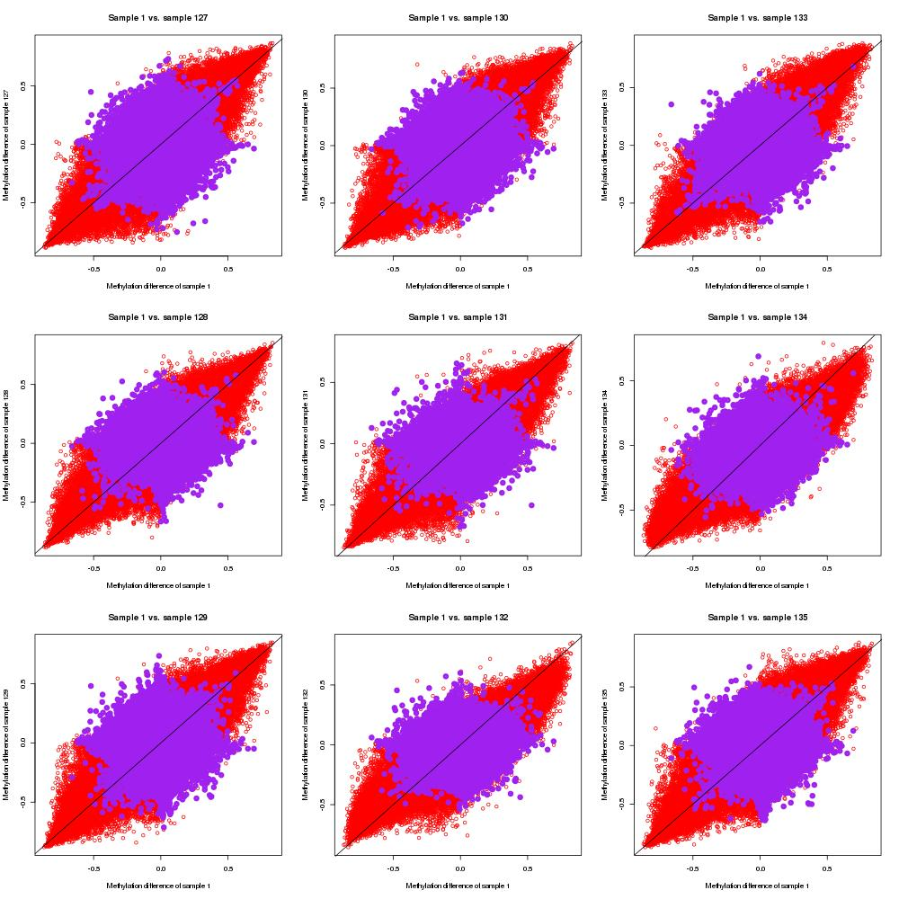Supplementary Figure 19. Scatter plots of measured placenta beta values-cord blood beta values, and measured placenta beta values-predicted placenta beta values by single-CpG-based SVM for sample #127 to #135
Red dots indicate (measured placenta beta values–measured cord blood beta values) of sample #1 and (measured placenta beta values–measured cord blood beta values) of sample i (#127 to #135), and purple dots represent (measured placenta beta values–predicted placenta beta values by single-CpG-based SVM) of sample #1 and (measured placenta beta values–predicted placenta beta values by single-CpG-based SVM) of sample i.
Note: “–“ represents minus sign.
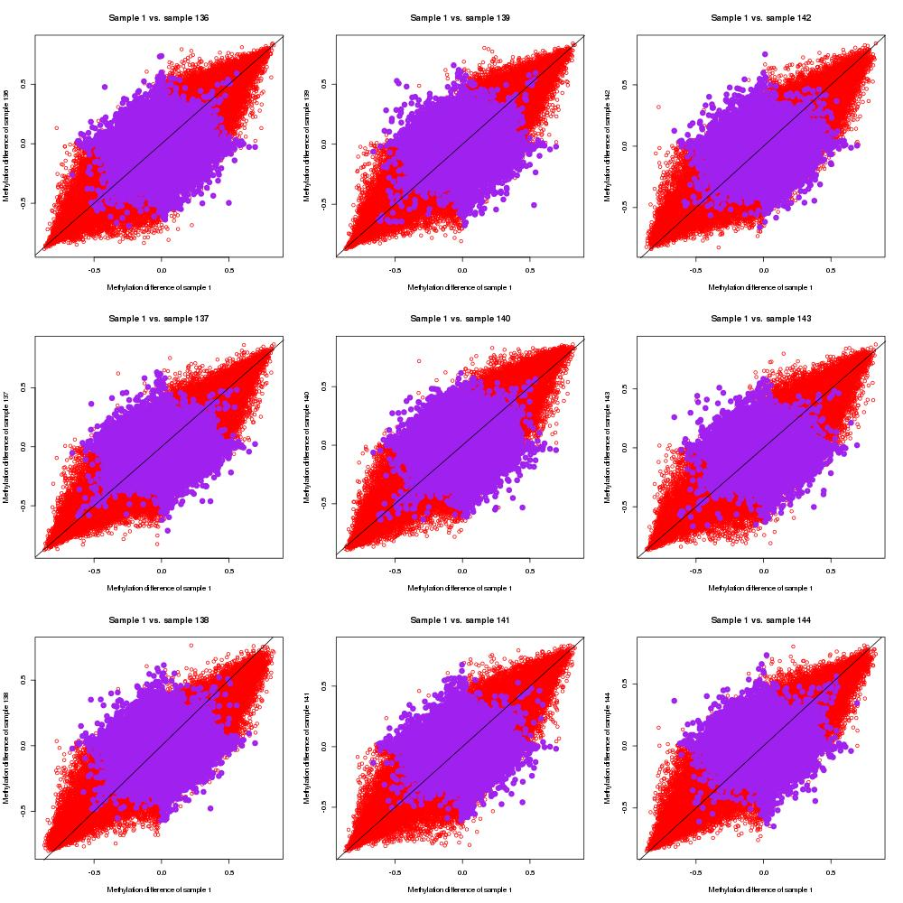Supplementary Figure 20. Scatter plots of measured placenta beta values-cord blood beta values, and measured placenta beta values-predicted placenta beta values by single-CpG-based SVM for sample #136 to #144
Red dots indicate (measured placenta beta values–measured cord blood beta values) of sample #1 and (measured placenta beta values–measured cord blood beta values) of sample i (#136 to #144), and purple dots represent (measured placenta beta values–predicted placenta beta values by single-CpG-based SVM) of sample #1 and (measured placenta beta values–predicted placenta beta values by single-CpG-based SVM) of sample i.
Note: “–“ represents minus sign.
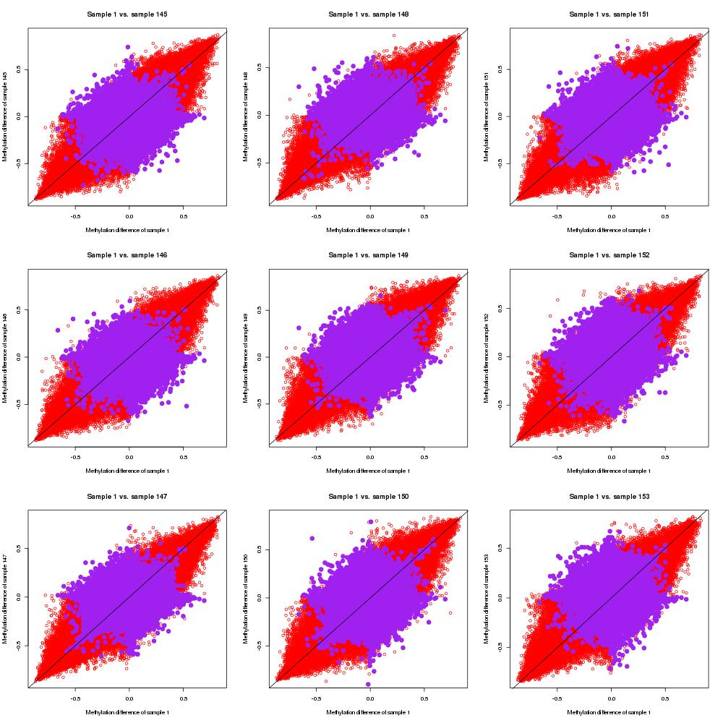Supplementary Figure 21. Scatter plots of measured placenta beta values-cord blood beta values, and measured placenta beta values-predicted placenta beta values by single-CpG-based SVM for sample #145 to #153
Red dots indicate (measured placenta beta values–measured cord blood beta values) of sample #1 and (measured placenta beta values–measured cord blood beta values) of sample i (#145 to #153), and purple dots represent (measured placenta beta values–predicted placenta beta values by single-CpG-based SVM) of sample #1 and (measured placenta beta values–predicted placenta beta values by single-CpG-based SVM) of sample i.
Note: “–“ represents minus sign.
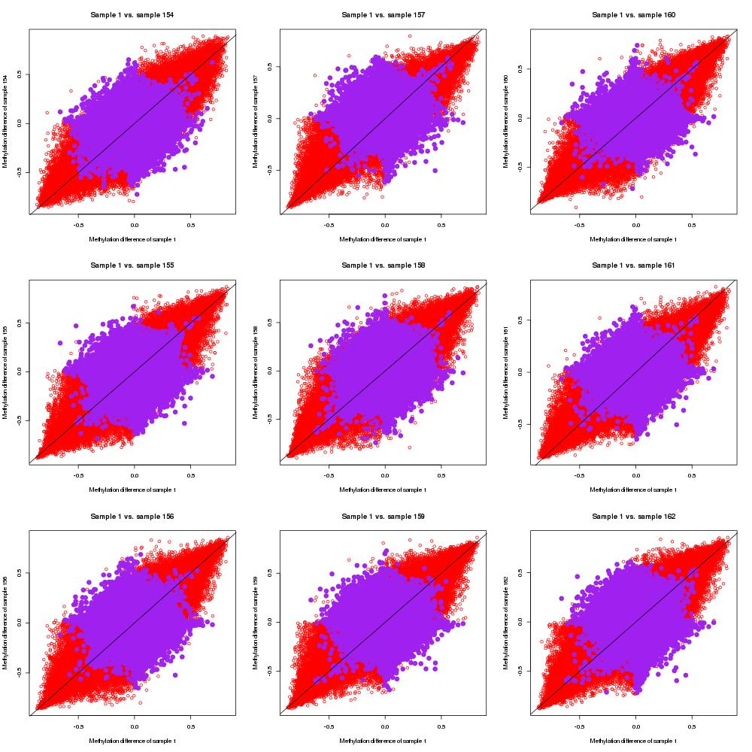Supplementary Figure 22. Scatter plots of measured placenta beta values-cord blood beta values, and measured placenta beta values-predicted placenta beta values by single-CpG-based SVM for sample #154 to #162
Red dots indicate (measured placenta beta values–measured cord blood beta values) of sample #1 and (measured placenta beta values–measured cord blood beta values) of sample i (#154 to #162), and purple dots represent (measured placenta beta values–predicted placenta beta values by single-CpG-based SVM) of sample #1 and (measured placenta beta values–predicted placenta beta values by single-CpG-based SVM) of sample i.
Note: “–“ represents minus sign.
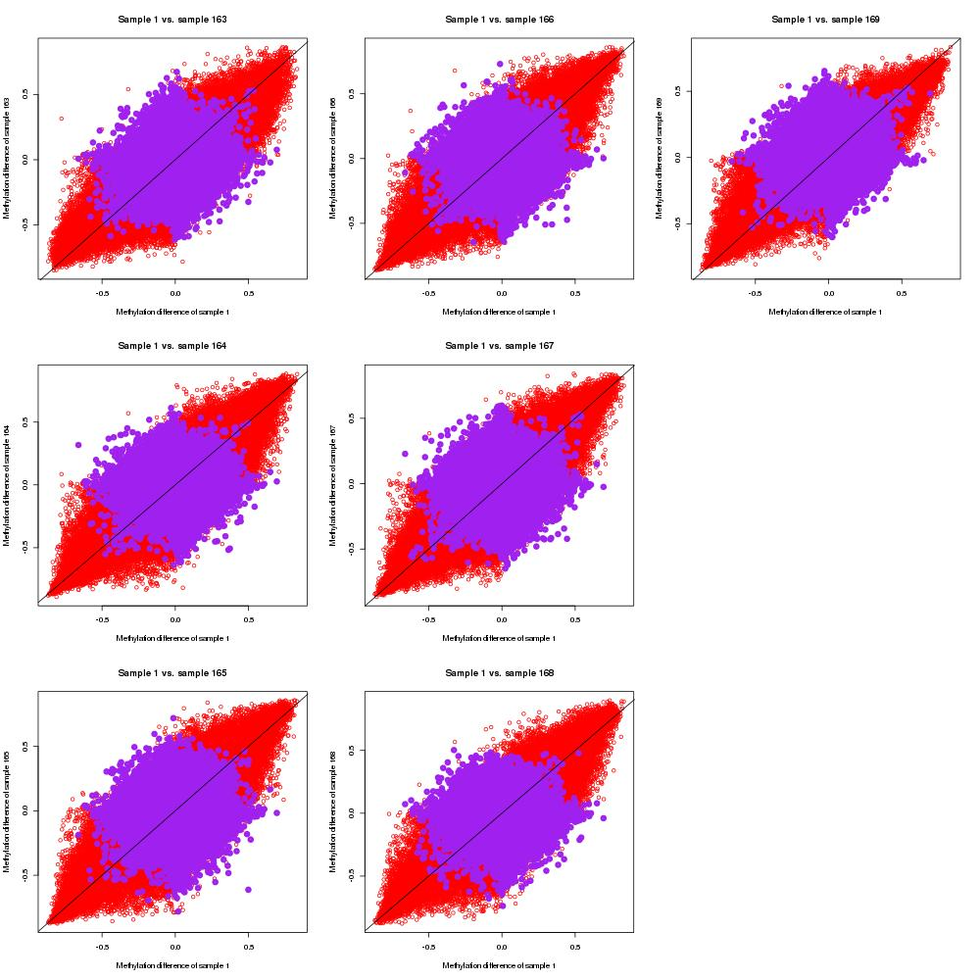Supplementary Figure 23. Scatter plots of measured placenta beta values-cord blood beta values, and measured placenta beta values-predicted placenta beta values by single-CpG-based SVM for sample #163 to #169
Red dots indicate (measured placenta beta values–measured cord blood beta values) of sample #1 and (measured placenta beta values–measured cord blood beta values) of sample i (#163 to #169), and purple dots represent (measured placenta beta values–predicted placenta beta values by single-CpG-based SVM) of sample #1 and (measured placenta beta values–predicted placenta beta values by single-CpG-based SVM) of sample i.
Note: “–“ represents minus sign.

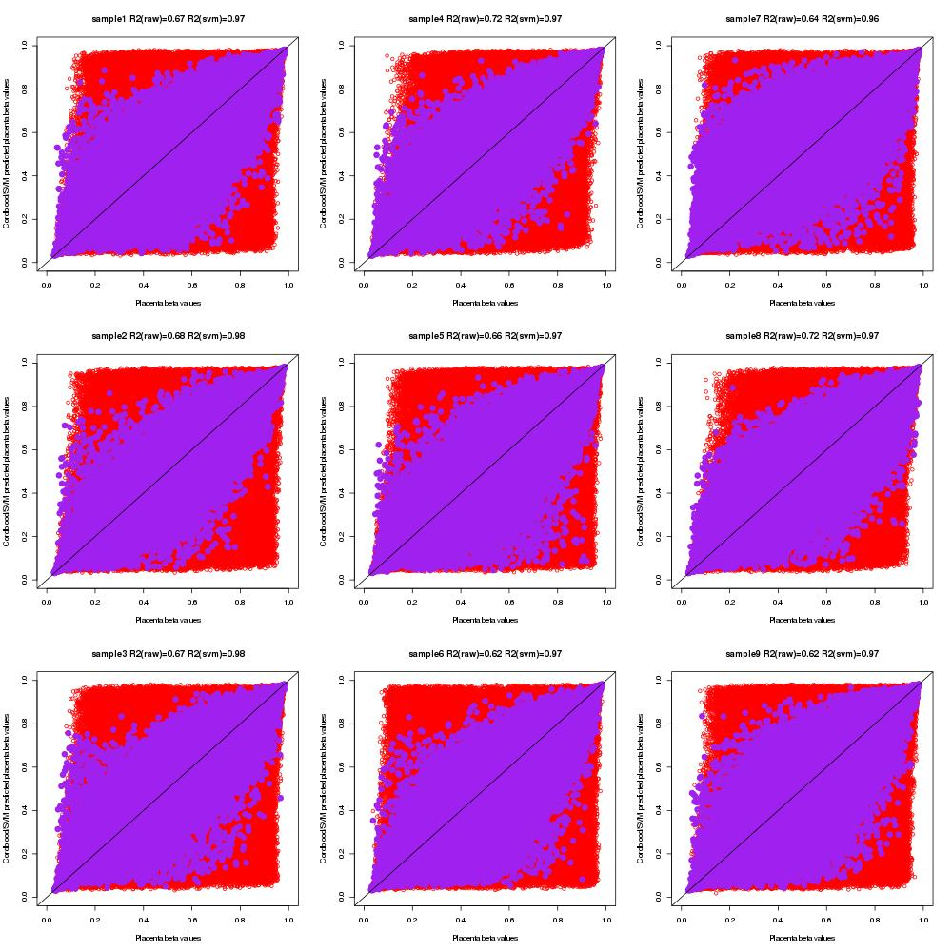Supplementary Figure 24. Scatter plots of measured cord blood beta values, measured placenta beta values and predicted placenta beta values by single-CpG-based SVM for sample #1 to #9
Red dots indicate measured placenta beta values and cord blood beta values, and purple dots represent measured placenta beta values and predicted placenta beta values by single-CpG-based SVM model.

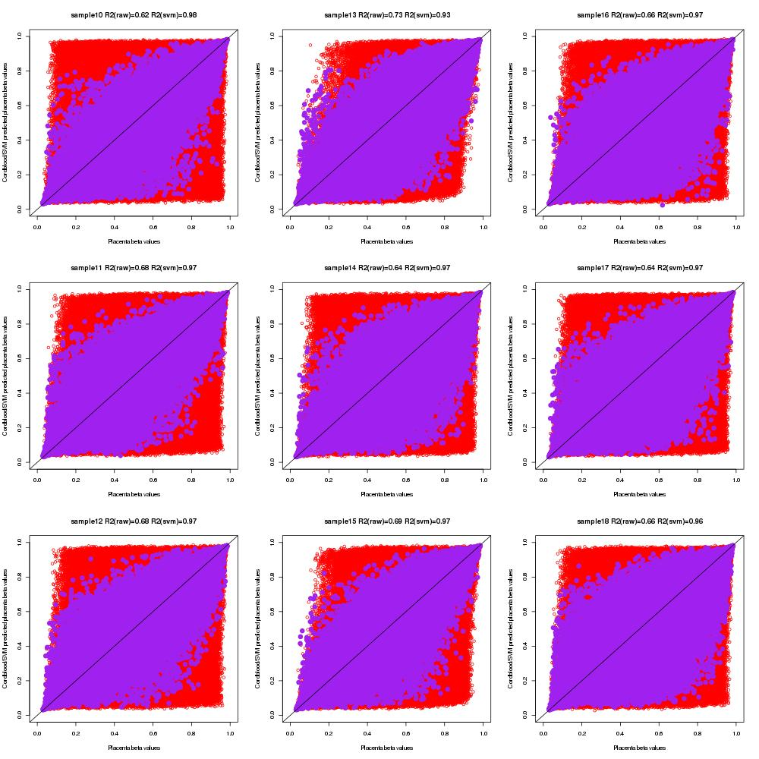Supplementary Figure 25. Scatter plots of measured cord blood beta values, measured placenta beta values and predicted placenta beta values by single-CpG-based SVM for sample #10 to #18
Red dots indicate measured placenta beta values and cord blood beta values, and purple dots represent measured placenta beta values and predicted placenta beta values by single-CpG-based SVM model.

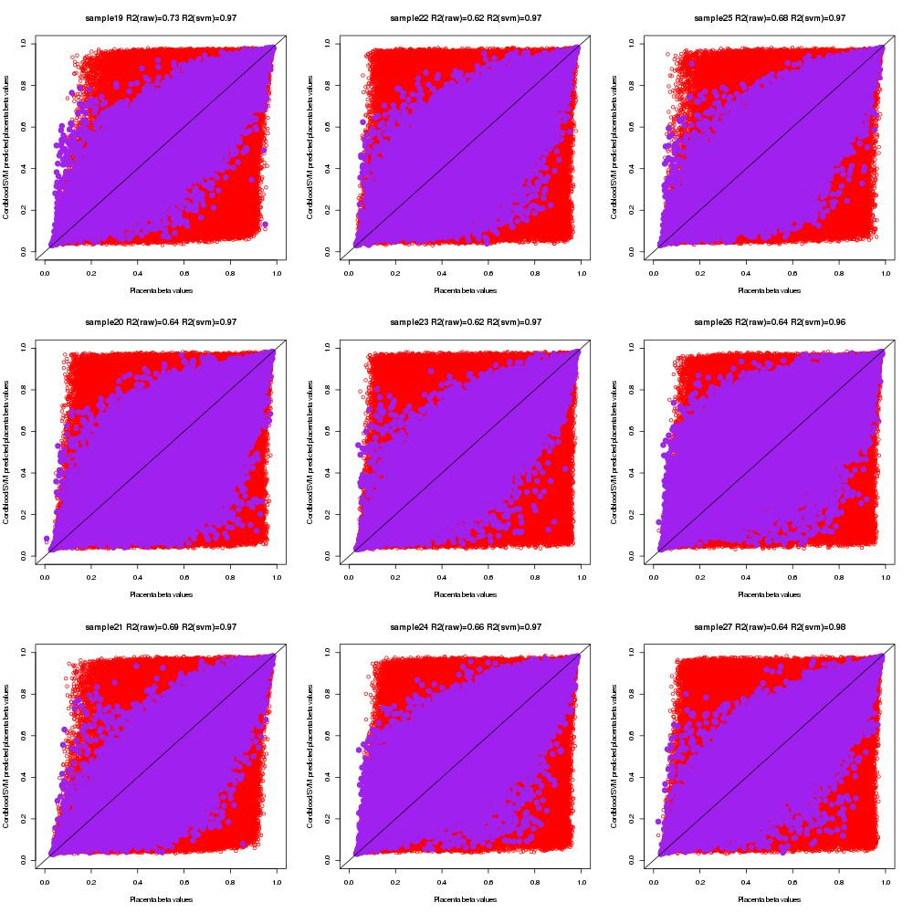Supplementary Figure 26. Scatter plots of measured cord blood beta values, measured placenta beta values and predicted placenta beta values by single-CpG-based SVM for sample #19 to #27
Red dots indicate measured placenta beta values and cord blood beta values, and purple dots represent measured placenta beta values and predicted placenta beta values by single-CpG-based SVM model.

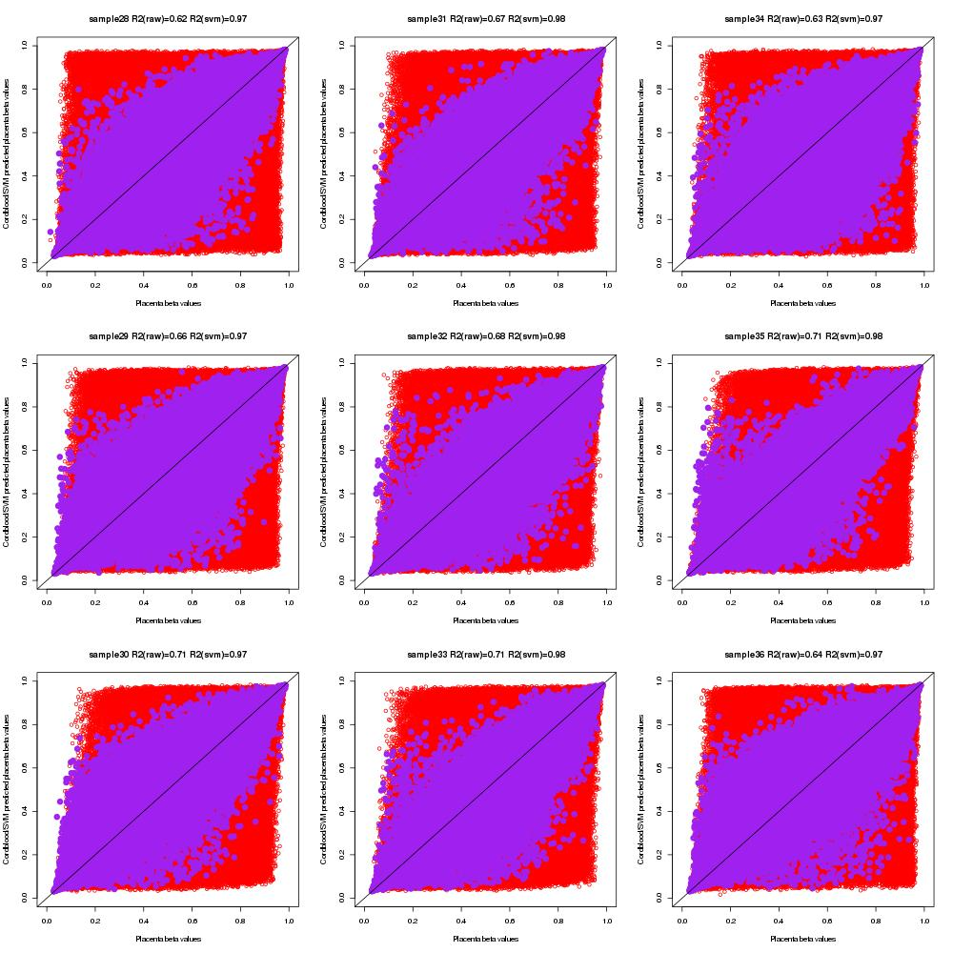Supplementary Figure 27. Scatter plots of measured cord blood beta values, measured placenta beta values and predicted placenta beta values by single-CpG-based SVM for sample #28 to #36
Red dots indicate measured placenta beta values and cord blood beta values, and purple dots represent measured placenta beta values and predicted placenta beta values by single-CpG-based SVM model.

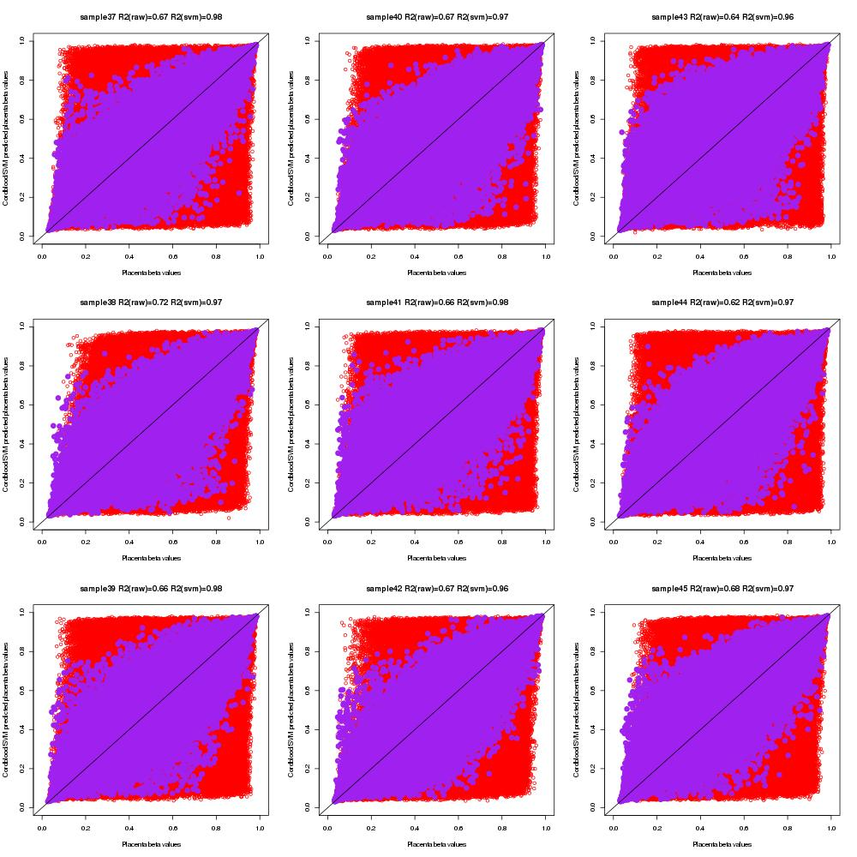Supplementary Figure 28. Scatter plots of measured cord blood beta values, measured placenta beta values and predicted placenta beta values by single-CpG-based SVM for sample #37 to #45
Red dots indicate measured placenta beta values and cord blood beta values, and purple dots represent measured placenta beta values and predicted placenta beta values by single-CpG-based SVM model.

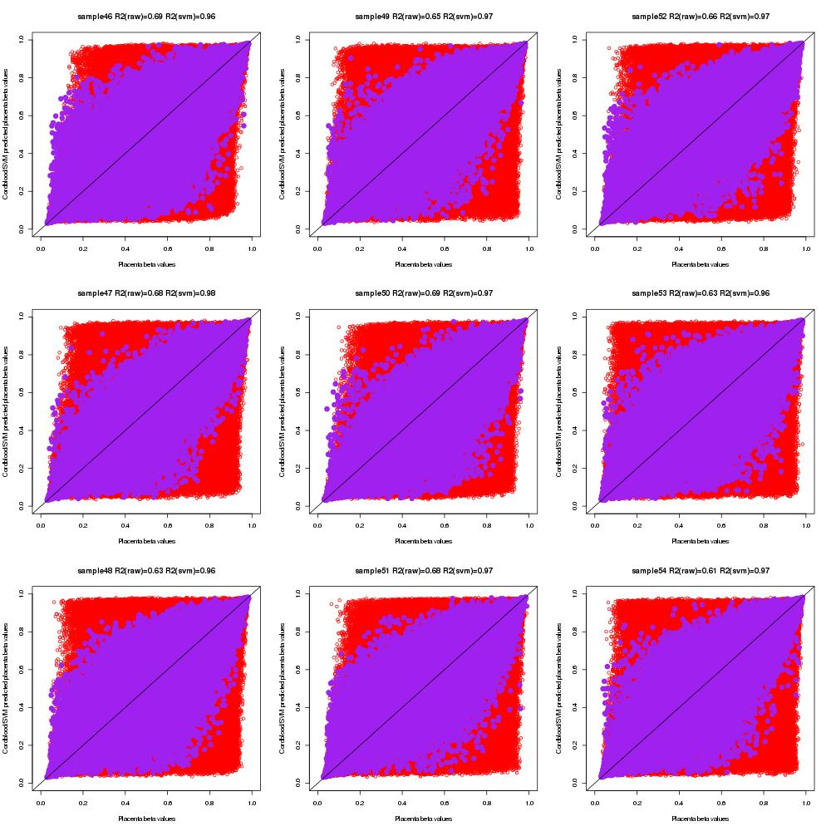Supplementary Figure 29. Scatter plots of measured cord blood beta values, measured placenta beta values and predicted placenta beta values by single-CpG-based SVM for sample #46 to #54
Red dots indicate measured placenta beta values and cord blood beta values, and purple dots represent measured placenta beta values and predicted placenta beta values by single-CpG-based SVM model.

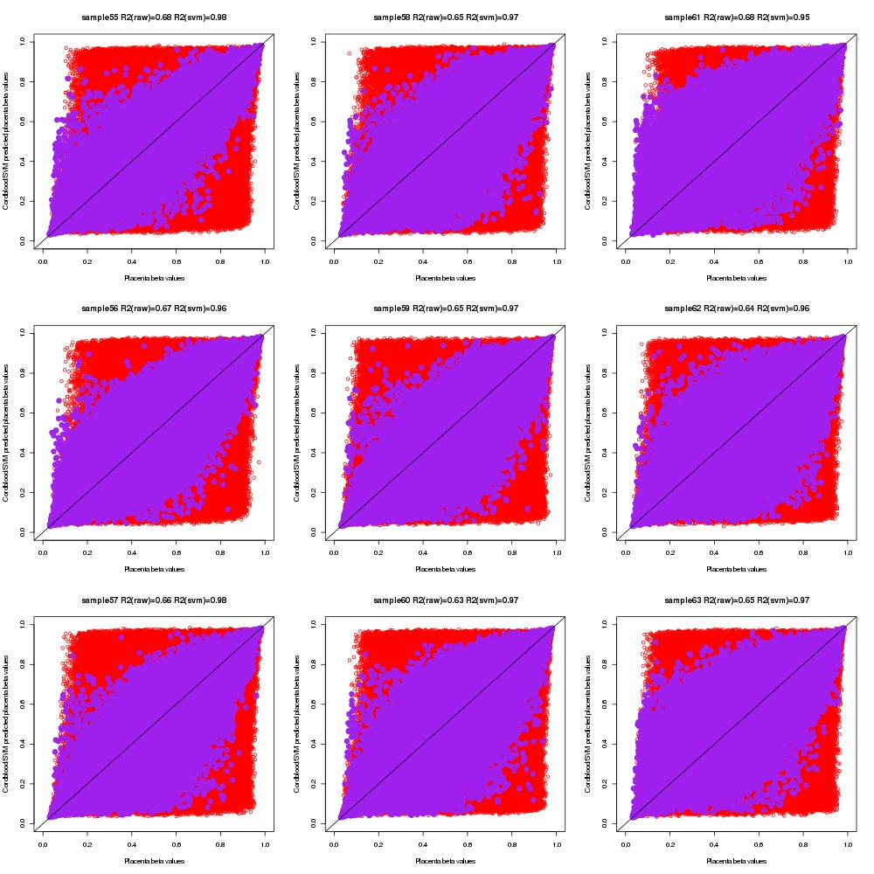Supplementary Figure 30. Scatter plots of measured cord blood beta values, measured placenta beta values and predicted placenta beta values by single-CpG-based SVM for sample #55 to #63
Red dots indicate measured placenta beta values and cord blood beta values, and purple dots represent measured placenta beta values and predicted placenta beta values by single-CpG-based SVM model.

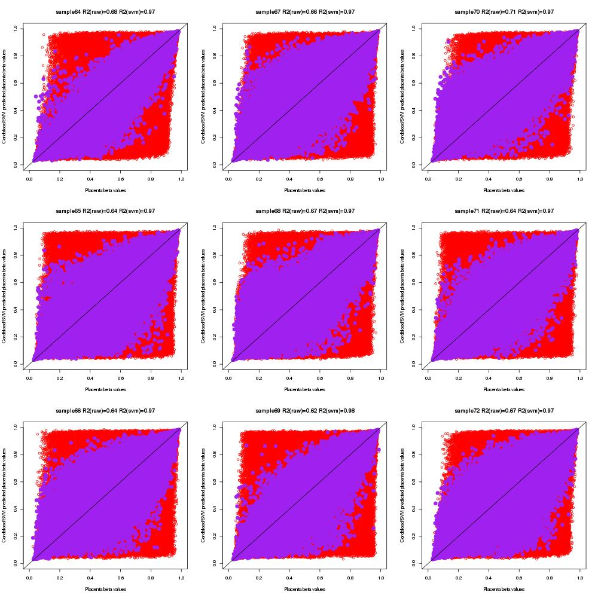Supplementary Figure 31. Scatter plots of measured cord blood beta values, measured placenta beta values and predicted placenta beta values by single-CpG-based SVM for sample #64 to #72
Red dots indicate measured placenta beta values and cord blood beta values, and purple dots represent measured placenta beta values and predicted placenta beta values by single-CpG-based SVM model.

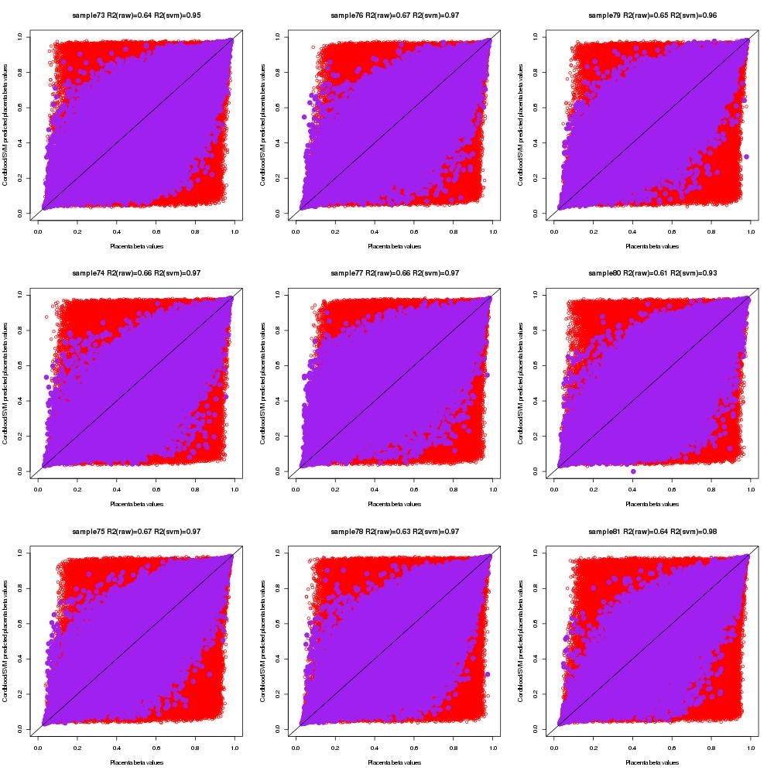Supplementary Figure 32. Scatter plots of measured cord blood beta values, measured placenta beta values and predicted placenta beta values by single-CpG-based SVM for sample #73 to #81
Red dots indicate measured placenta beta values and cord blood beta values, and purple dots represent measured placenta beta values and predicted placenta beta values by single-CpG-based SVM model.

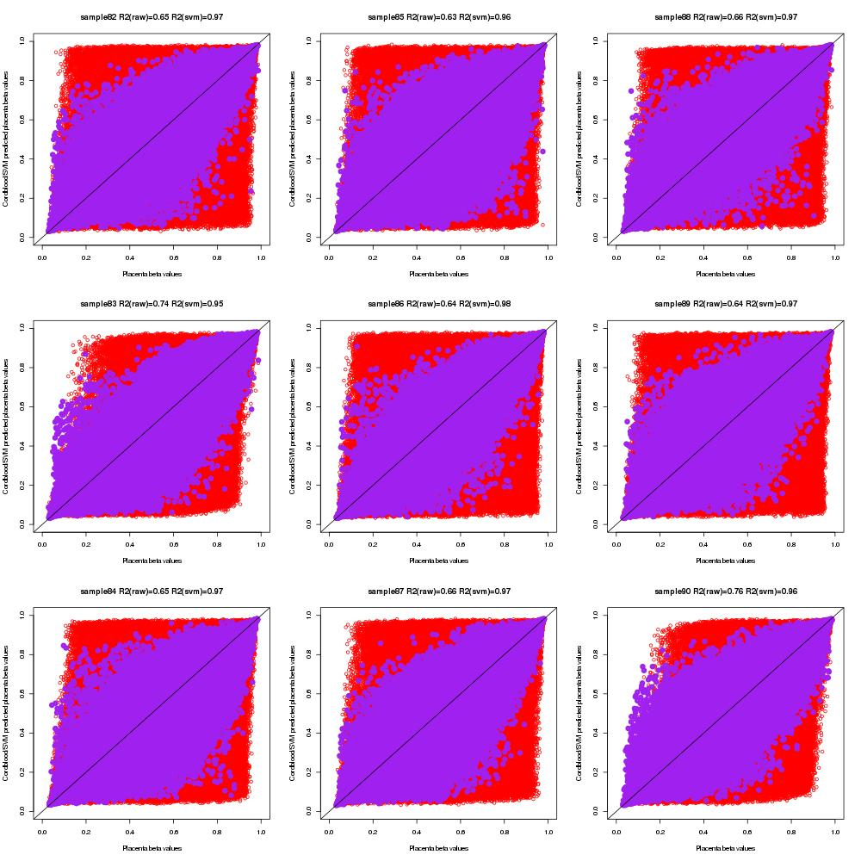Supplementary Figure 33. Scatter plots of measured cord blood beta values, measured placenta beta values and predicted placenta beta values by single-CpG-based SVM for sample #82 to #90
Red dots indicate measured placenta beta values and cord blood beta values, and purple dots represent measured placenta beta values and predicted placenta beta values by single-CpG-based SVM model.

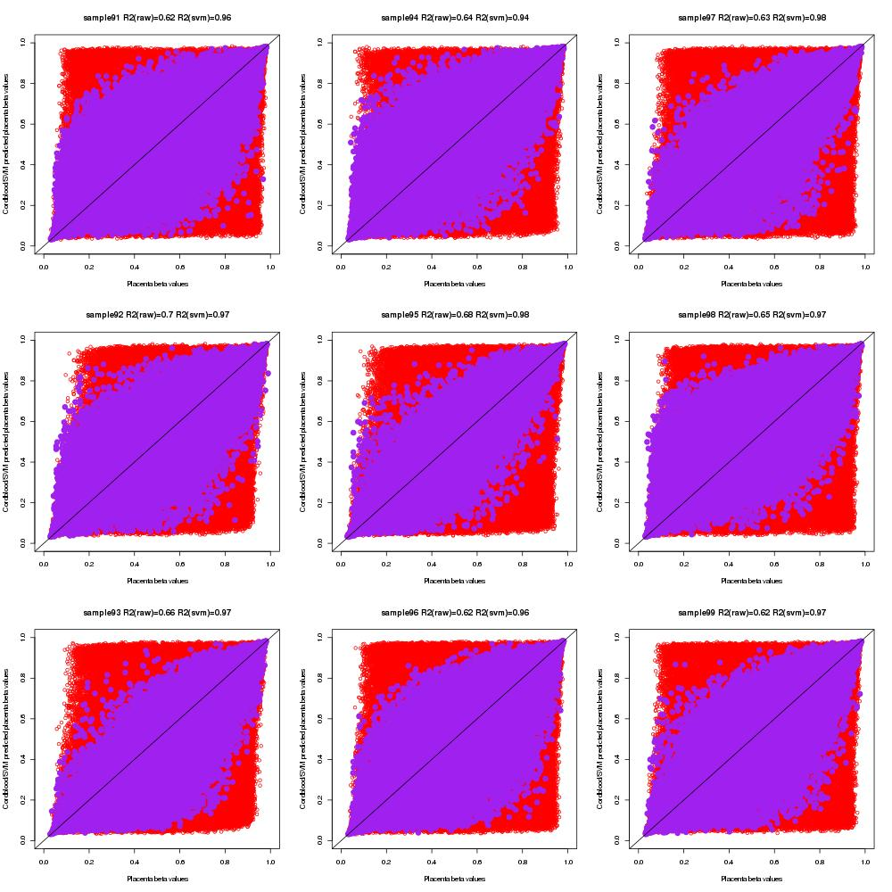Supplementary Figure 34. Scatter plots of measured cord blood beta values, measured placenta beta values and predicted placenta beta values by single-CpG-based SVM for sample #91 to #99
Red dots indicate measured placenta beta values and cord blood beta values, and purple dots represent measured placenta beta values and predicted placenta beta values by single-CpG-based SVM model.

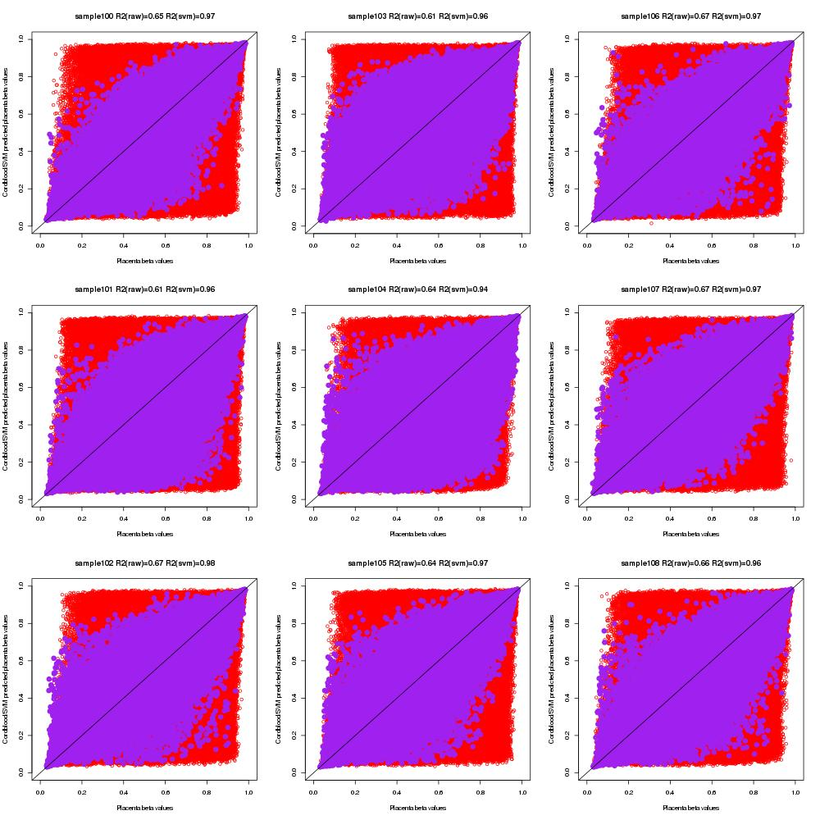Supplementary Figure 35. Scatter plots of measured cord blood beta values, measured placenta beta values and predicted placenta beta values by single-CpG-based SVM for sample #100 to #108
Red dots indicate measured placenta beta values and cord blood beta values, and purple dots represent measured placenta beta values and predicted placenta beta values by single-CpG-based SVM model.

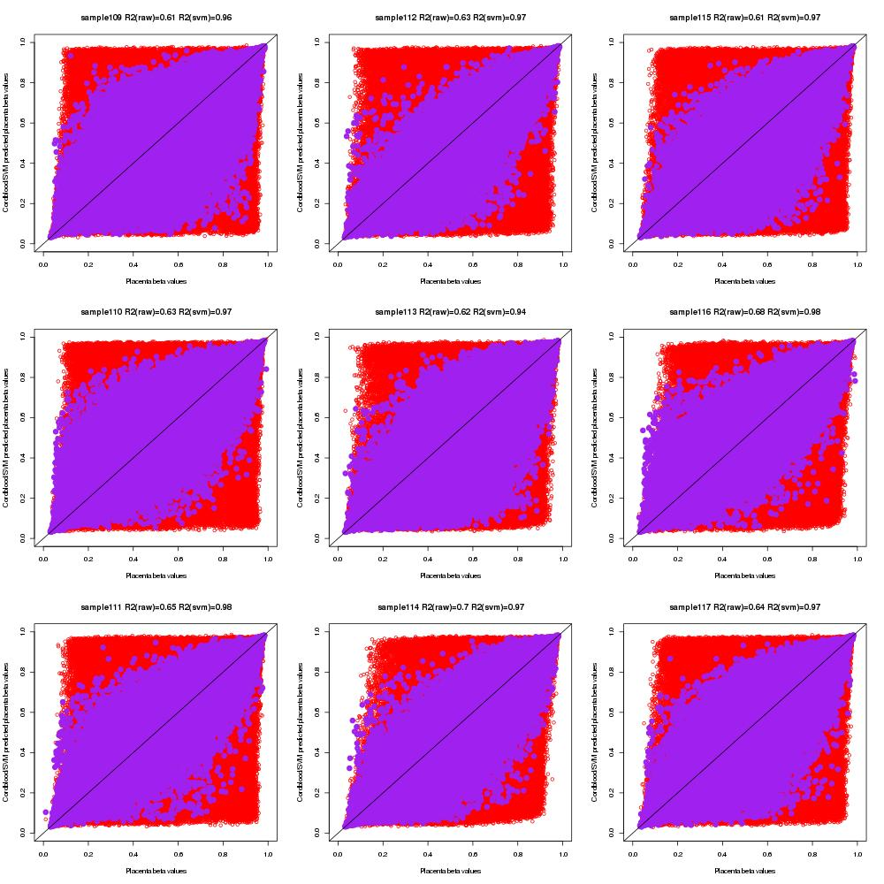Supplementary Figure 36. Scatter plots of measured cord blood beta values, measured placenta beta values and predicted placenta beta values by single-CpG-based SVM for sample #109 to #117
Red dots indicate measured placenta beta values and cord blood beta values, and purple dots represent measured placenta beta values and predicted placenta beta values by single-CpG-based SVM model.

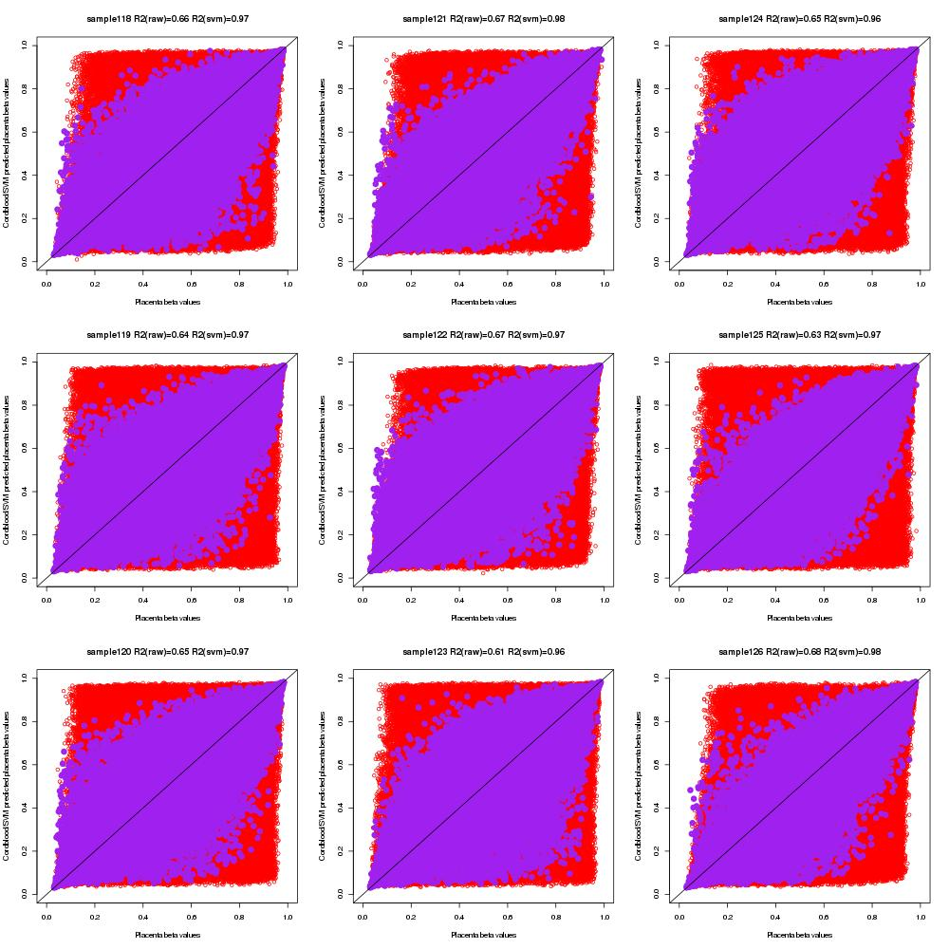Supplementary Figure 37. Scatter plots of measured cord blood beta values, measured placenta beta values and predicted placenta beta values by single-CpG-based SVM for sample #118 to #126
Red dots indicate measured placenta beta values and cord blood beta values, and purple dots represent measured placenta beta values and predicted placenta beta values by single-CpG-based SVM model.

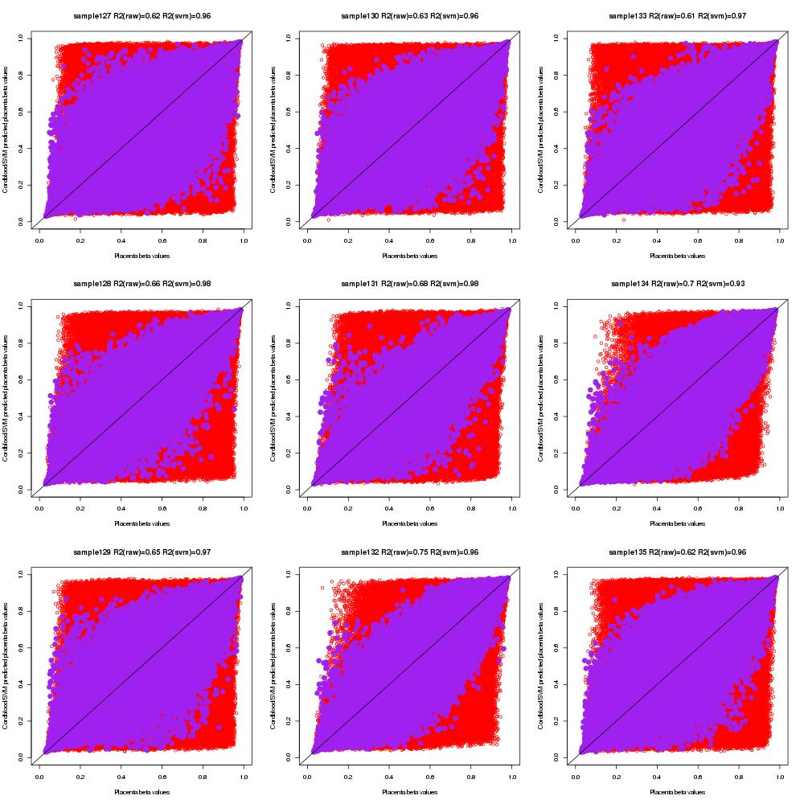Supplementary Figure 38. Scatter plots of measured cord blood beta values, measured placenta beta values and predicted placenta beta values by single-CpG-based SVM for sample #126 to #135
Red dots indicate measured placenta beta values and cord blood beta values, and purple dots represent measured placenta beta values and predicted placenta beta values by single-CpG-based SVM model.

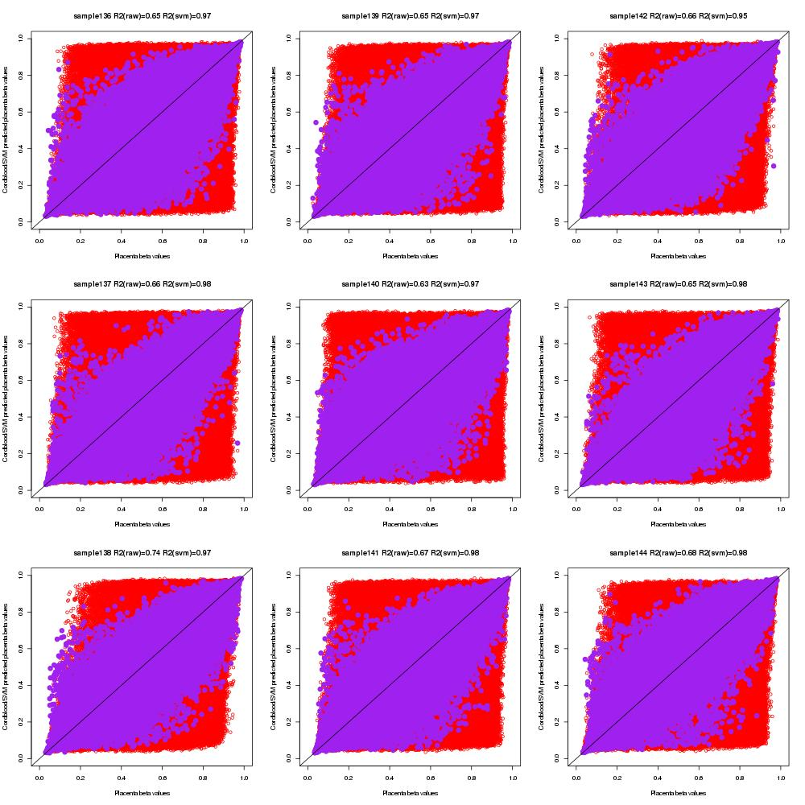Supplementary Figure 39. Scatter plots of measured cord blood beta values, measured placenta beta values and predicted placenta beta values by single-CpG-based SVM for sample #136 to #144
Red dots indicate measured placenta beta values and cord blood beta values, and purple dots represent measured placenta beta values and predicted placenta beta values by single-CpG-based SVM model.

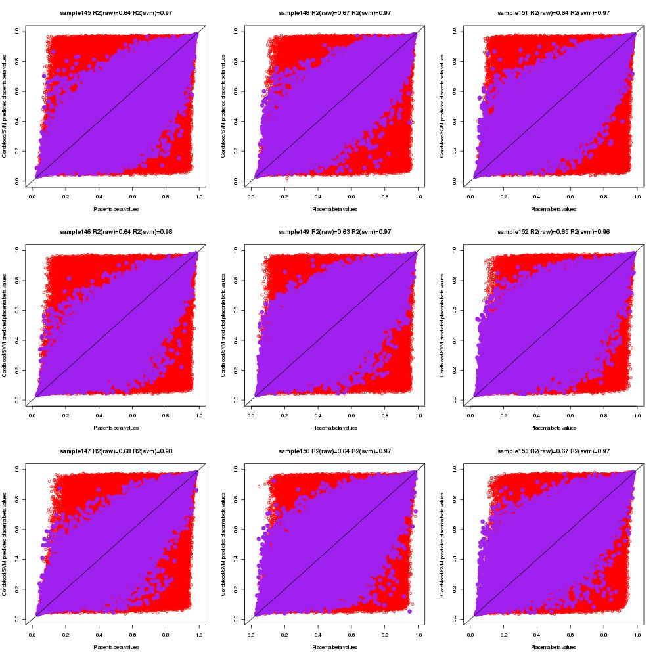Supplementary Figure 40. Scatter plots of measured cord blood beta values, measured placenta beta values and predicted placenta beta values by single-CpG-based SVM for sample #145 to #153
Red dots indicate measured placenta beta values and cord blood beta values, and purple dots represent measured placenta beta values and predicted placenta beta values by single-CpG-based SVM model.

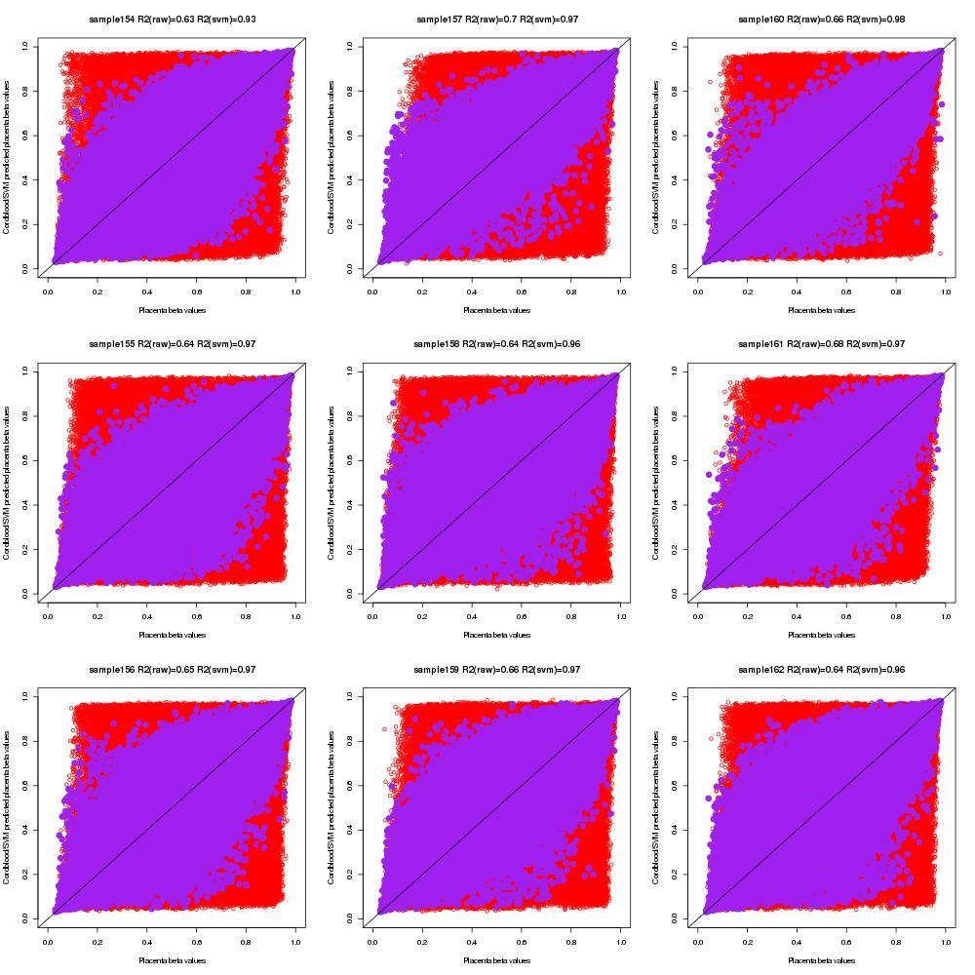Supplementary Figure 41. Scatter plots of measured cord blood beta values, measured placenta beta values and predicted placenta beta values by single-CpG-based SVM for sample #154 to #162
Red dots indicate measured placenta beta values and cord blood beta values, and purple dots represent measured placenta beta values and predicted placenta beta values by single-CpG-based SVM model.

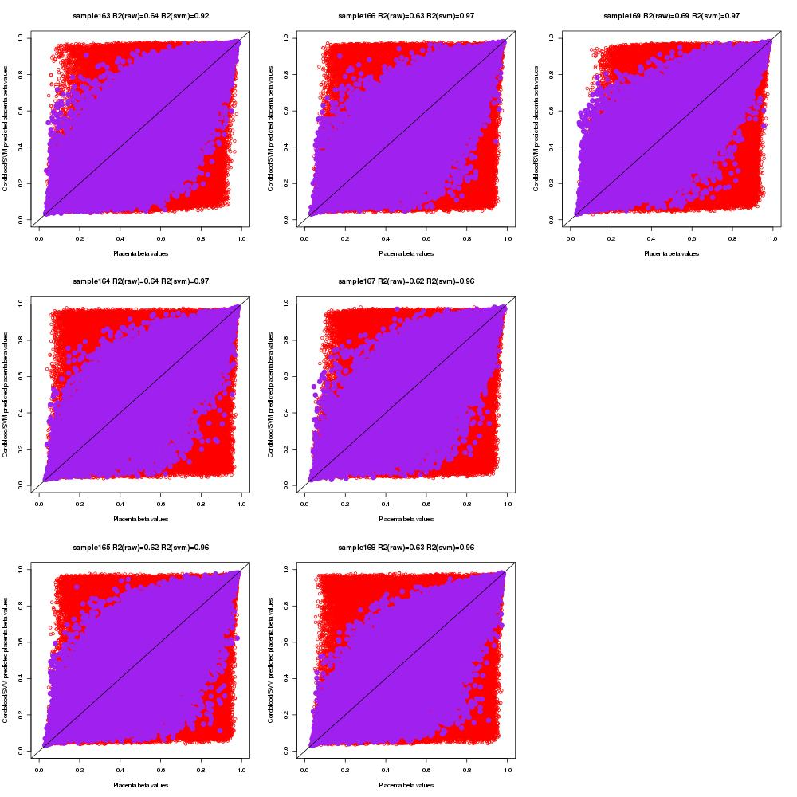Supplementary Figure 42. Scatter plots of measured cord blood beta values, measured placenta beta values and predicted placenta beta values by single-CpG-based SVM for sample #163 to #169
Red dots indicate measured placenta beta values and cord blood beta values, and purple dots represent measured placenta beta values and predicted placenta beta values by single-CpG-based SVM model.

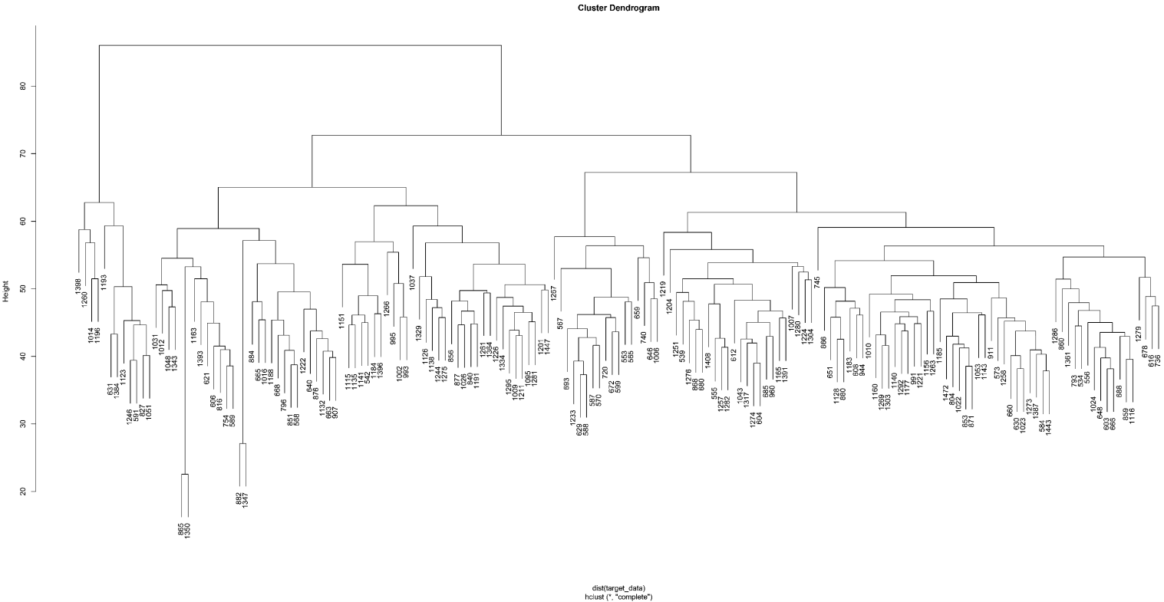
#4
#3
#1
#2

Supplementary Figure 43A. Clustering of measured placenta methylation

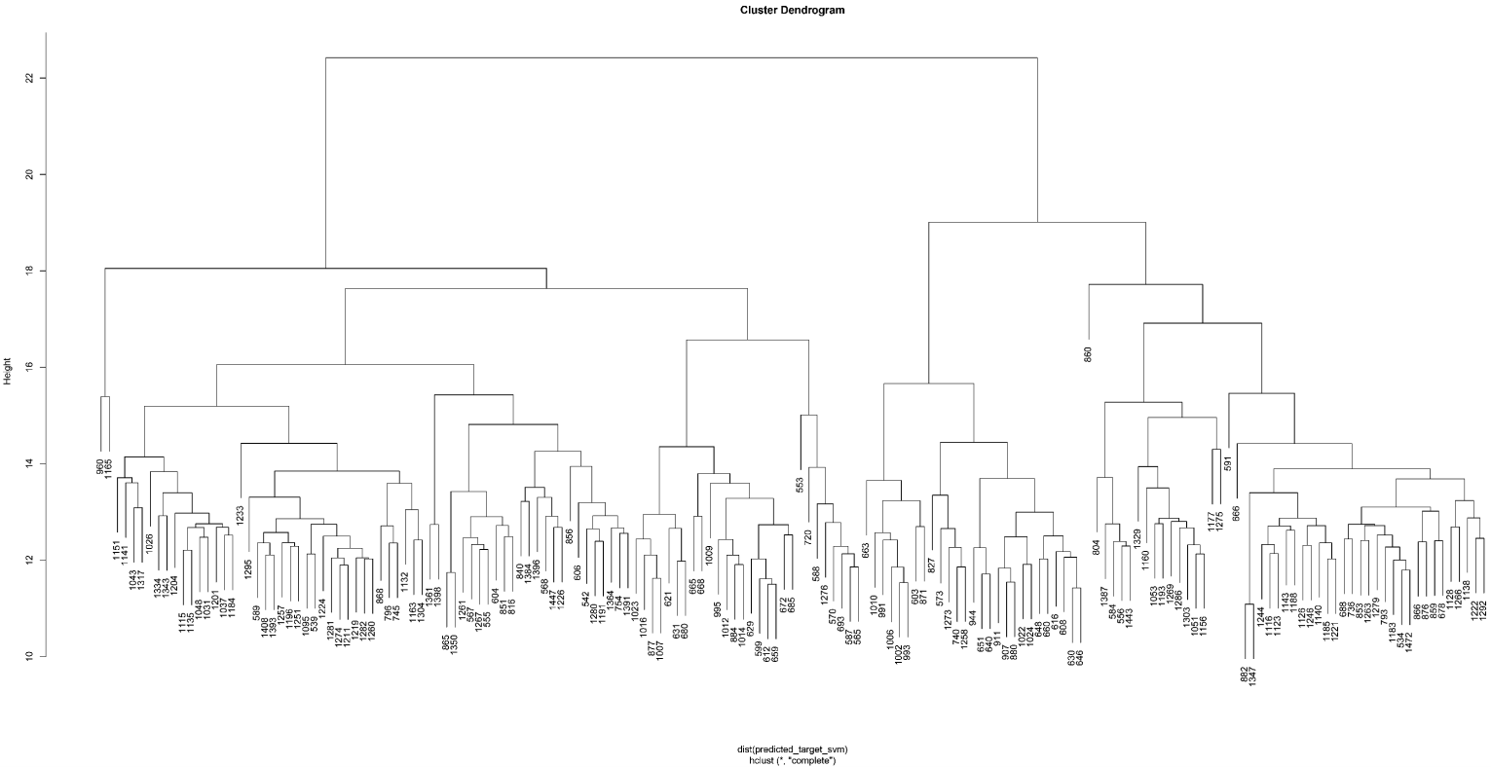
#4
#3
#2
#1
42.31%
64.71%
8.33%
59.68%

Supplementary Figure 43B. Clustering of predicted placenta methylation

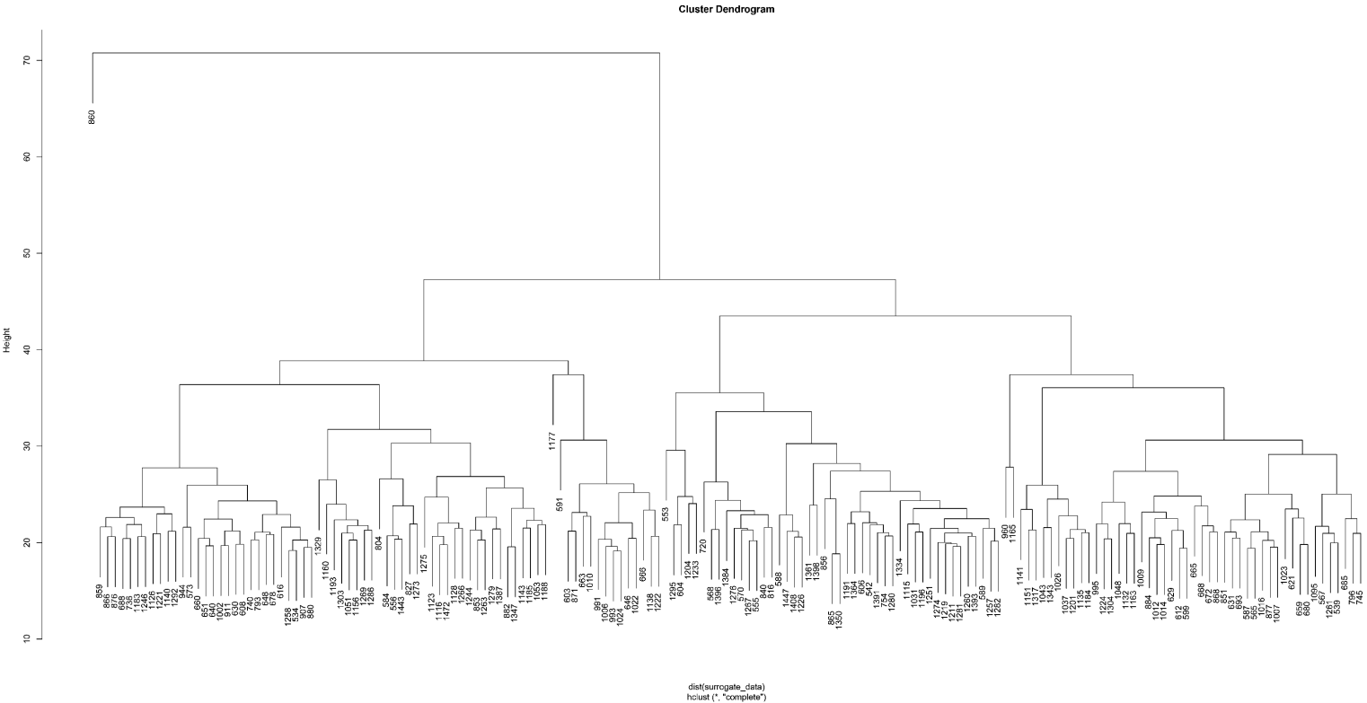
#4
#3
#2
#1
8.33%
35.48%
47.06%
53.85%

Supplementary Figure 43C. Clustering of measured cord blood methylation

