🪩💃🏽🕺🏾
Digital Safety DiscoTechDrop in & take action in suport of your digital safety—right now!
🪩💃🏼🕺🏿
Table A
Search for yourself online and set up Google Alerts

TABLE A Instructions
Visit this link: hsph.me/GoogleAlerts
Or scan the QR Code
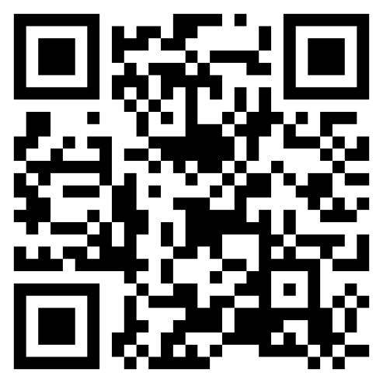

Table B

Set up two-factor authentication (2FA)

TABLE B Instructions
Visit this link:
hsph.me/2FA
Or scan the QR Code
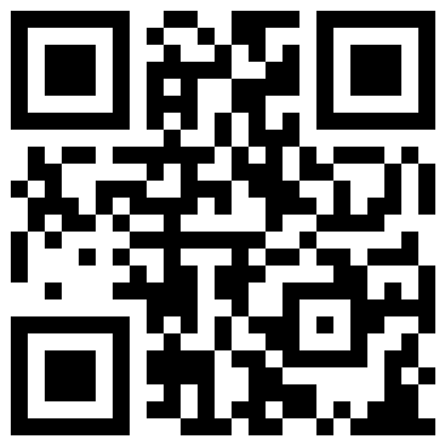

Table C
Make data deletion requests

TABLE C Instructions
Visit this link:
hsph.me/DataDeletion
Or scan the QR Code
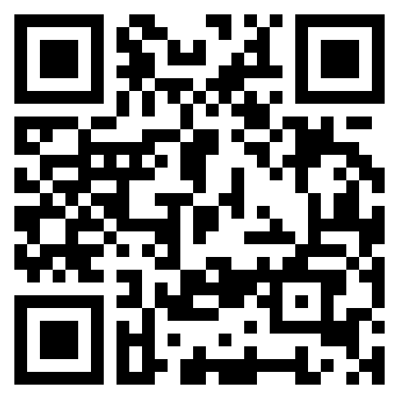

Table D
Change some passwords

TABLE D Instructions
Visit this link:
hsph.me/Passwords
Or scan the QR Code 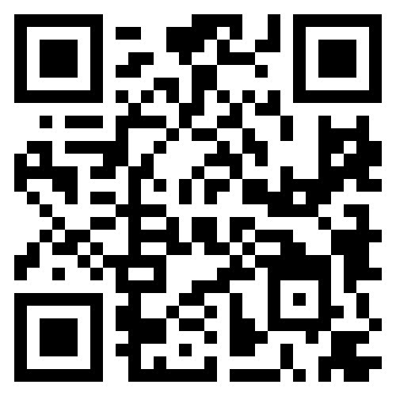

Table E
Celebrate your progress

Celebrate Progress
Visit this link:
hsph.me/CelebrateProgress
Or scan the QR Code
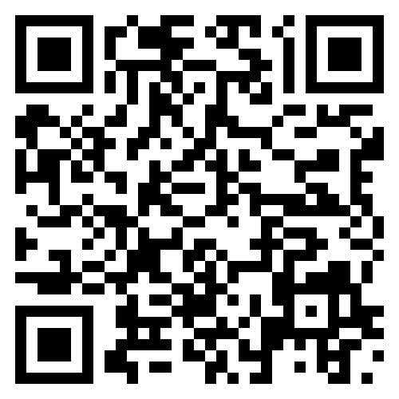

Table F
Make alternate contact info

Make alternate contact info

Visit this link:
hsph.me/AlternateInfo
Or scan the QR Code
